

Trademarks

Autel® and MaxiCharger® are trademarks of Autel Intelligent Technology Corp., Ltd., registered in China, the United States and other countries. All other marks are trademarks or registered trademarks of their respective holders.

Copyright Information

No part of this manual may be reproduced, stored in a retrieval system or transmitted, in any form or by any means, electronic, mechanical, photocopying, recording, or otherwise without the prior written permission of Autel.

Disclaimer of Warranties and Limitation of Liabilities

All information, specifications and illustrations in this manual are based on the latest information available at the time of printing.

Autel reserves the right to make changes at any time without notice. While information of this manual has been carefully checked for accuracy, no guarantee is given for the completeness and correctness of the contents, including but not limited to the product specifications, functions, and illustrations.

Autel will not be liable for any direct, special, incidental, indirect damages or any economic consequential damages (including the loss of profits).

IMPORTANT

Before operating or maintaining this unit, please read this manual carefully, paying extra attention to the safety warnings and precautions.

For Services and Support:

Web: www.autelenergy.com

Tel: +49 (0) 89 540299608 (Europe)

0086-755-2267-2493 (China)

Email: support.eu@autel.com

For technical assistance in all other markets, please contact your local selling agent.

**CONTENTS**

[1 Using This Manual 1](#_Toc131778913)

[1.1 Conventions 1](#_Toc131778914)

[1.1.1 Bold Text 1](#_Toc131778915)

[1.1.2 Notes 1](#_Toc131778916)

[1.1.3 Hyperlinks 1](#_Toc131778917)

[1.1.4 Revision History 2](#_Toc131778918)

[1.2 Terminology 3](#_Toc131778919)

[2 Safety 4](#_Toc131778920)

[2.1 Safety Warnings 4](#_Toc131778921)

[2.2 Owner Responsibilities 4](#_Toc131778922)

[2.3 Installation Engineer Qualifications 5](#_Toc131778923)

[2.4 Usage Instructions 5](#_Toc131778924)

[2.5 Symbols on the MaxiCharger 5](#_Toc131778925)

[2.6 Disposal Instructions 6](#_Toc131778926)

[2.7 Cyber Security 6](#_Toc131778927)

[3 General Introduction 7](#_Toc131778928)

[3.1 Product Overview 8](#_Toc131778929)

[3.2 Working Principle Diagram 13](#_Toc131778930)

[3.3 Local Service Portal 14](#_Toc131778931)

[3.4 Cloud Service Portal 15](#_Toc131778932)

[4 Preparation 16](#_Toc131778933)

[4.1 Before Installing 16](#_Toc131778934)

[4.2 Unpacking 17](#_Toc131778935)

[4.3 Moving the Cabinet to the Site 18](#_Toc131778936)

[4.3.1 Hoisting the Cabinet 18](#_Toc131778937)

[4.3.2 Forklifting the Cabinet 19](#_Toc131778938)

[4.4 Packing List 20](#_Toc131778939)

[4.5 Installation Tools 22](#_Toc131778940)

[5 Installation 23](#_Toc131778941)

[5.1 Preparing the Installation Site 24](#_Toc131778942)

[5.1.1 Location Requirements 25](#_Toc131778955)

[5.1.2 Preparing the Foundation 28](#_Toc131778956)

[5.2 Installing the Cabinet 33](#_Toc131778957)

[5.3 Preparing for Electrical Cable Installation 36](#_Toc131778958)

[5.4 Electrical Wiring 37](#_Toc131778959)

[5.4.1 Connecting the PE Wire 37](#_Toc131778960)

[5.4.2 Connecting the Enclosure to the earth 38](#_Toc131778961)

[5.4.3 Connecting the AC Input Wires 39](#_Toc131778962)

[5.4.4 Connecting the Ethernet Cable 40](#_Toc131778963)

[5.4.5 Installing SIM Card 41](#_Toc131778964)

[5.5 Installing the Charging Modules 42](#_Toc131778965)

[5.6 Installing the External Residual-current Device 45](#_Toc131778966)

[5.7 Preparing for Commissioning 46](#_Toc131778967)

[6 Operation 47](#_Toc131778968)

[6.1 Before Use 47](#_Toc131778969)

[6.2 Emergency Stop 48](#_Toc131778970)

[6.3 Charging Procedure 49](#_Toc131778971)

[6.3.1 Screen Layout 49](#_Toc131778972)

[6.3.2 Authorization 50](#_Toc131778973)

[6.3.3 Start Charging 51](#_Toc131778974)

[6.3.4 Charging 52](#_Toc131778975)

[6.3.5 Stop Charging 53](#_Toc131778976)

[6.3.6 Finish Charging 53](#_Toc131778977)

[6.4 Charging Errors 54](#_Toc131778978)

[6.4.1 Connector Connection Error 54](#_Toc131778979)

[6.4.2 Authorization Failure 54](#_Toc131778980)

[6.4.3 Charging Start Failure 54](#_Toc131778981)

[6.4.4 Charging Failure 54](#_Toc131778982)

[6.5 Energizing the MaxiCharger 54](#_Toc131778983)

[6.6 De-energizing the MaxiCharger 55](#_Toc131778984)

[6.6.1 Measuring the AC Voltage 55](#_Toc131778985)

[6.6.2 Measuring the DC Voltage 56](#_Toc131778986)

[6.7 Removing Condensation 57](#_Toc131778987)

[6.8 Local Service Portal Operations 58](#_Toc131778988)

[6.8.1 Setting the OCPP Parameters 58](#_Toc131778989)

[7 Maintenance 59](#_Toc131778990)

[7.1 Routine Maintenance 59](#_Toc131778991)

[7.1.1 Residual Current Device Maintenance 59](#_Toc131778992)

[7.1.2 Cleaning the Cabinet 60](#_Toc131778993)

[7.1.3 Cleaning and Replacing the Air Filters 60](#_Toc131778994)

[7.2 Inspection and Maintenance 63](#_Toc131778995)

[7.3 Remote Maintenance 63](#_Toc131778996)

[7.4 Maintenance Schedule 64](#_Toc131778997)

[8 Troubleshooting and Service 65](#_Toc131778998)

[8.1 Troubleshooting 65](#_Toc131778999)

[8.2 Service 67](#_Toc131779000)

[9 Technical Specifications 68](#_Toc131779001)

[9.1 General Specifications 68](#_Toc131779002)

[9.2 Packaging Specifications 70](#_Toc131779003)

[9.3 Installation Specifications 71](#_Toc131779004)

[9.4 Communication Interface Specifications 73](#_Toc131779005)

[9.5 Power Rating Specifications 74](#_Toc131779006)

[9.6 AC Input and DC Output Specifications 75](#_Toc131779007)

[9.7 Power Consumption Specifications 77](#_Toc131779008)

[9.8 Input Short Circuit Current Specifications 77](#_Toc131779009)

# Using This Manual

This manual contains device usage instructions.

Some illustrations shown in this manual may contain modules and optional equipment that are not included in your system. Contact your sales representative for availability of other modules and optional tools or accessories.

The document is intended for these groups:

* Owner of the MaxiCharger (see Owner Responsibilities)
* Installation engineer (see Installation Engineer Qualifications)

## Conventions

### Bold Text

Bold text is used to highlight selectable items such as buttons and menu options. Example:

* Tap **OK**.

### Notes

* **NOTE**: provides helpful information such as additional explanations, tips, and comments.
* **IMPORTANT**: indicates a situation that, if not avoided, may result in damage to the test equipment or vehicle.
* **DANGER**: indicates an imminently hazardous situation which, if not avoided, will result in death or serious injury to the operator or bystanders.
* **WARNING**: indicates a potentially hazardous situation which, if not avoided, could result in death or serious injury to the operator or bystanders.
* **CAUTION**: indicates that disobeying the instruction can cause damage to the equipment or property.

### Hyperlinks

Hyperlinks are available in electronic documents. Blue italic text indicates a selectable hyperlink and blue underlined text indicates a website link or an email address link.

### Revision History

|  |  |  |
| --- | --- | --- |
| **Version** | **Date** | **Descriptions** |
| V1 | 2022.09.28 | Initial version |
| V1.1 | 2022.11.11 | Complete overhaul |
| V2 | 2023.03.27 | Model updated  2.1 Fire protection added  3.2 Figure 3-3 updated  4.2 Unpacking updated  5.5 Installing the charging module updated. |

## Terminology

Table ‑ Terminology

| **Term** | **Definition** |
| --- | --- |
| **AC** | Alternating current |
| **CCS** | Combined Charging System; a standard charging method for electric vehicles |
| **CCU** | Charging Control Unit; a control unit used to communicate with BMS, and control the power delivery to the EV |
| **CHAdeMO** | Abbreviation of CHArge de Move; a standard charging  method for electric vehicles |
| **DC** | Direct current |
| **ECU** | Equipment Control Unit; a control unit used to handle the system protection and the charging module control and distribution |
| **EV** | Electric vehicle |
| **OCPP** | Open charge point protocol; open standard for communication with charge stations |
| **PE** | Protective earth (ground) |
| **RCBO** | Residual current breaker with overload |
| **RCD** | Residual current device; a device that breaks an electrical circuit when it detects a current leakage |
| **RFID** | Radio-frequency identification; a method of charging authentication |
| **SOC** | State of charge; the level of charge of an electric battery relative to its capacity. 0%=empty; 100%=full |
| **SPD** | Surge protection device; a device intended to protect electrical devices from voltage spikes in AC circuits |
| **TCU** | Transaction Control Unit; intelligent hardware to handle the human-machine interface, metering, transaction, and communication with back office |

# Safety

## Safety Warnings

* Disconnect the power supply to the MaxiCharger during the entire installation procedure.
* The load capacity of the grid must meet the requirements of the MaxiCharger.
* Connect the MaxiCharger to a grounded, metal, permanent wiring system. Otherwise, use the equipment-grounding conductor with the circuit conductors and connect it to the equipment grounding terminal or lead on the product.
* Unqualified personnel must keep a safe distance during the entire installation procedure.
* The connections to the MaxiCharger must comply with all applicable local rules.
* Only use electrical wires of sufficient gauge and insulation to handle the rated current and voltage demand.
* Protect the wiring inside the MaxiCharger from damage and do not obstruct the wiring when you perform maintenance on the cabinet.
* Keep the cabinet away from all water source.
* Protect the MaxiCharger with safety devices and measures as specified by local rules.
* Wear proper personal protective equipment such as protective clothing, safety gloves, safety shoes, and safety glasses when necessary.
* Do not install or use this equipment near flammable, explosive, harsh, or combustible materials, chemicals or vapors.
* If applicable, install a fire alarm system nearby this equipment to detect early fires.

## Owner Responsibilities

The MaxiCharger owner runs the MaxiCharger for commercial or business purposes for itself or third-party usage. To protect the user, other employees, or third parties, the owner bears legal responsibility for the operation of the charger and has the following responsibilities:

* Identify any hazards (in terms of a risk assessment) resulting from the working conditions on the site.
* Know and implement all local rules.
* Install protective devices before operating the MaxiCharger.
* Make sure all protective devices are installed after installation or maintenance work.
* Prepare an emergency plan that instructs people what to do in case of an emergency.
* Make sure that all employees and third parties are qualified in accordance with the applicable local rules to perform their work.
* Make sure that there is sufficient space around the MaxiCharger to safely do maintenance and installation work.
* Identify a site operator who is responsible for the safe operation of the MaxiCharger and for the coordination of all work, if the owner does not do these tasks.
* Make sure that all qualified installation engineers obey local rules and installation instructions, and adhere to the specifications of the MaxiCharger.

## Installation Engineer Qualifications

The installation engineers must:

* Be qualified in accordance with all applicable local rules to do the work.
* Be completely familiar with the MaxiCharger and its safe installation.
* Obey all local rules and the instructions in the installation manual.

## Usage Instructions

Do not use the MaxiCharger and immediately contact the manufacturer if any of the following situations occur:

* Damaged enclosure
* Damaged EV charging cable or connector
* Expose to lightning
* Expose to water
* Expose to nature disaster, fire or smoke

## Symbols on the MaxiCharger

Table ‑ Symbol Description

| Symbol | Risk Description |
| --- | --- |
|  | General risk |
|  | Hazardous voltage with risk of electrocution |
|  | Waste from electrical and electronic equipment |
|  | Hot surface with risk of burn injuries |

## Disposal Instructions

To avoid negative effect on the environment and human health due to potential hazardous substances, dispose of parts according to local laws and guidance. Proper disposal of this product will allow for the reuse the materials and protect the environment.

## Cyber Security

NOTE

This section applies only to the Ethernet and Wi-Fi connections.

The MaxiCharger can use a network interface for connection and information and data communication. The owner bears the responsibility of providing a secure connection between the MaxiCharger and the owner’s network or any other networks.

Appropriate measures shall be taken by the owner to shield the MaxiCharger, the network, the system, and the interface from any security breaches, unauthorized access, interference, intrusion, leakage and/or theft of data or information. These measures may include firewalls, authentication methods, data encryption, anti-virus programs, etc.

Autel is not liable for damages and/or losses resulting from security breaches.

# General Introduction

The Autel MaxiCharger is designed to charge an electric vehicle (hereinafter called EV). Our chargers provide you with safe, reliable, fast, and smart charging solutions.

The MaxiCharger is intended for the DC charging of EVs and is intended for both indoor and outdoor use in fleets, highway rest stops, commercial parking garages, and other locations.

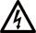DANGER

* If you use the MaxiCharger in any way other than described in its documentation, you can cause death, injury, and property damage.
* Use the MaxiCharger only as intended.

NOTE

The images and illustrations depicted in this manual may differ slightly from the actual product.

This manual will instruct you how to install and operate the MaxiCharger.

## Product Overview

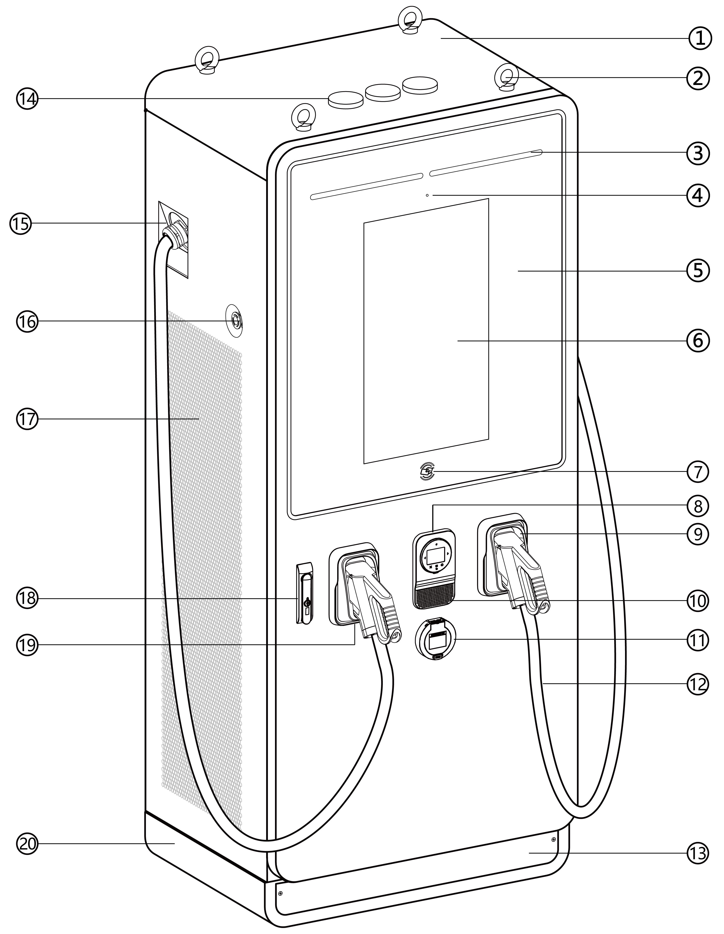

***Figure 3‑1*** MaxiCharger Overview, Outside

1. Main Cabinet
2. Eye Bolt — for equipment movement, loading and unloading
3. Status Indicator — displays the current status of the MaxiCharger
4. Light Sensor
5. Tempered Glass — protects indicator and touchscreen, etc.
6. Touchscreen (the size of the touchscreen is optional)
7. RFID Card Reader
8. Point of Sale (POS) Terminal (the shape might varies depending on the terminal you choose)
9. Holster
10. Loudspeaker
11. Socket (optional)
12. Front Cabinet Door
13. Front/Rear Base Cover — you can move the device using a forklift after removing the cover
14. Antenna
15. Waterproof Cable Fixing Connector — for the extended charging cable
16. Emergency Stop Button
17. Vent
18. Handle Lock
19. Connector
20. Base

NOTE

Autel can deliver the MaxiCharger with different payment terminals. The available options vary depending on the region and country where the MaxiCharger is installed. If you need more information about different options for the payment terminals, consult Autel customer support.

Table ‑ Status Indicator Key

| **Charging Status** | **Color** | **Meaning** |
| --- | --- | --- |
| **Standby Mode** | Solid Green | The connector is available. |
| **EV Connected** | Solid White | An EV is connected to the MaxiCharger. |
| **Charging** | Illuminating Green in Turn | Indicates how much of your EV is charged. |
| **Charge Complete** | Flashing Green | An EV is fully charged or has stopped charging. |
| **Reservation** | Flashing White | The MaxiCharger is reserved. |
| **Error** | Solid Red | An error has occurred. |

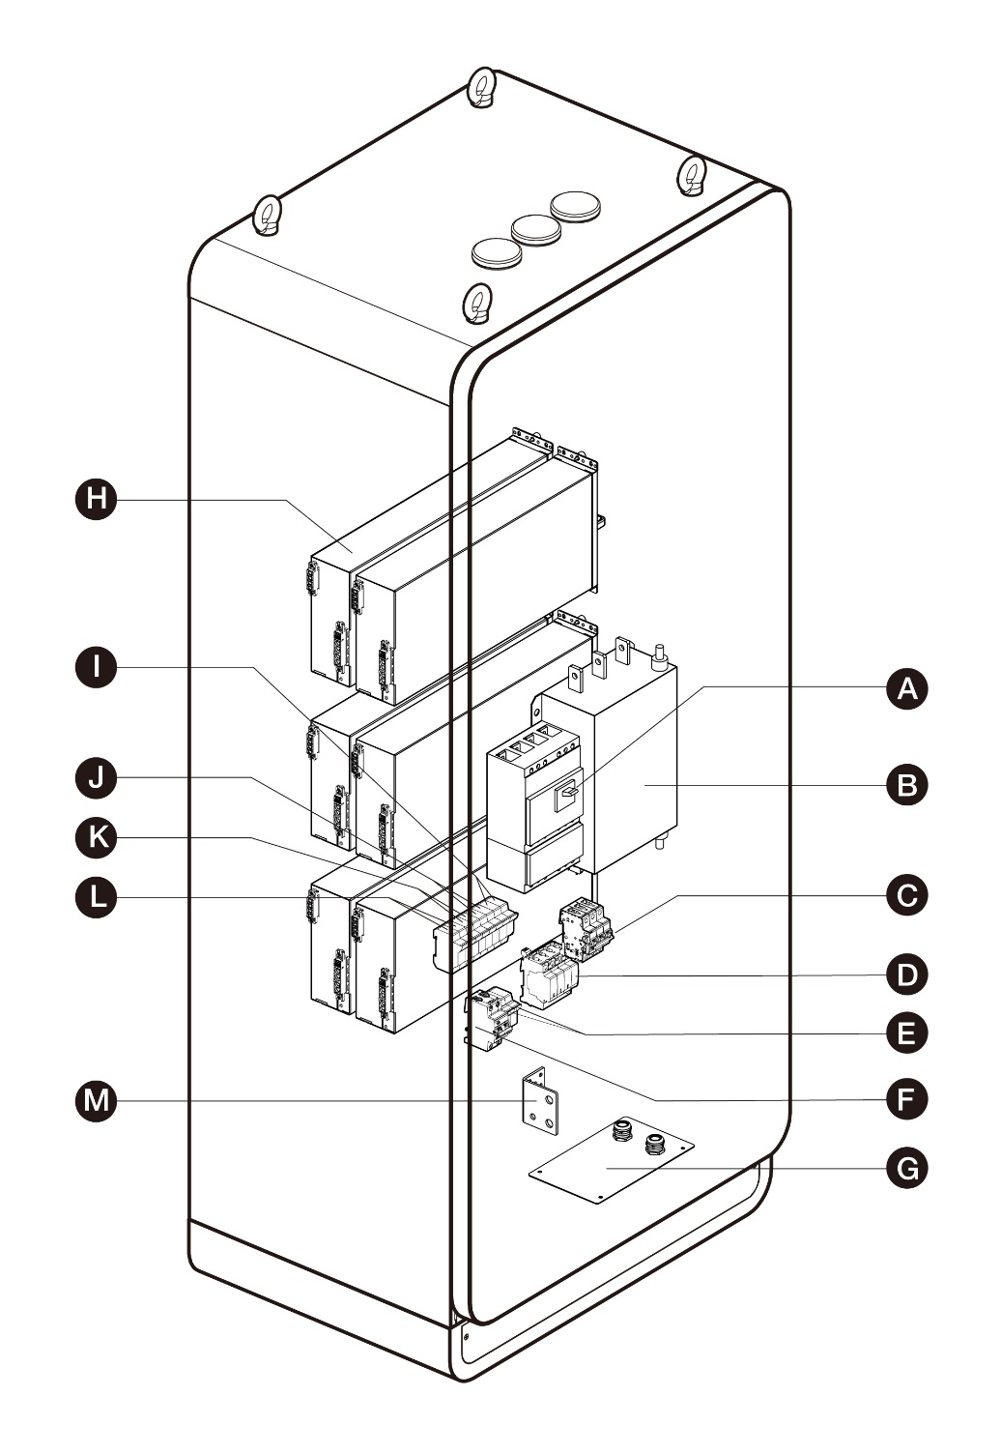

Figure ‑MaxiCharger Overview, Inside

A. Main Breaker — connects/disconnects the charging module

B. AC Filter (optional)

C. SPD Breaker

D. SPD

E. Auxiliary AC Main Fuse

F. Auxiliary RCCB

G. Cable Gland Plate

H. Charging Module

I. Heater Circuit Fuse

J. Contactor Circuit Fuse

K. 48V Auxiliary AC Fuse

L. 24V Auxiliary AC Fuse

M. PE Busbar — connects the PE cable

## Working Principle Diagram

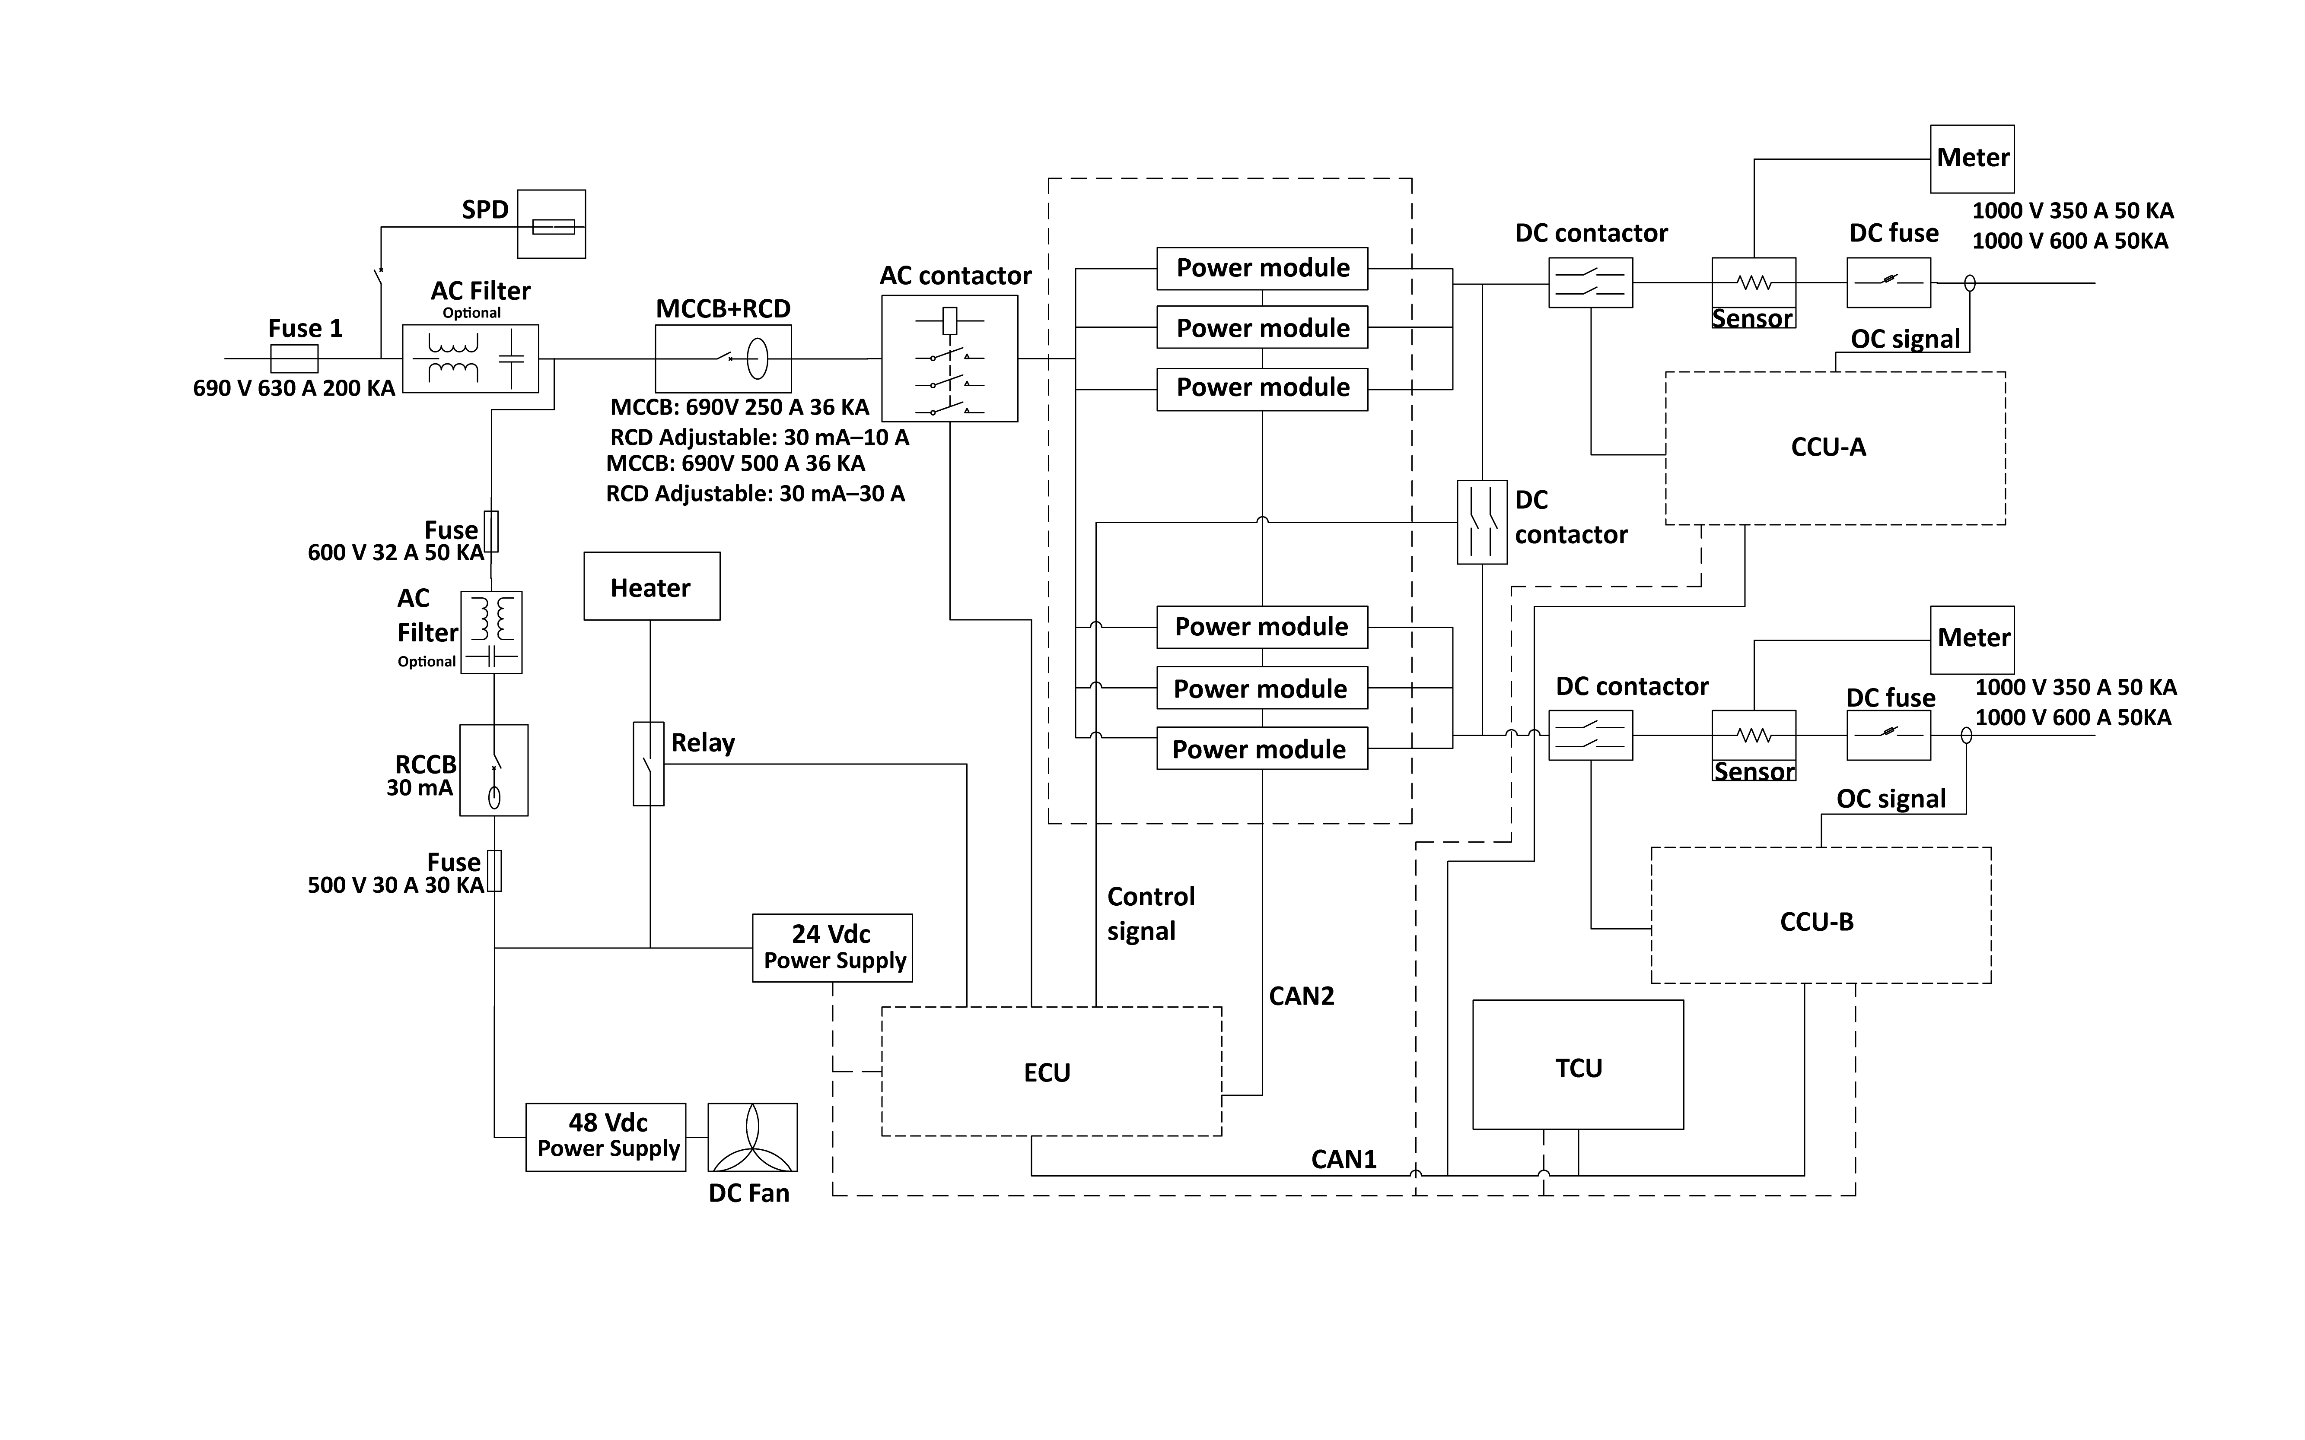Figure ‑ Working Principle View

NOTE

* Fuse 1 is used when the power rate of the MaxiCharger exceeds 120 kW.
* The number of used power modules varies according to the power rate of the MaxiCharger.

## Local Service Portal

The Local Service Portal provides information about the MaxiCharger, allows for the configuration of the key parameters during commissioning, and enables diagnostics on site. For detailed operation procedures, see Local Service Portal Operations.

Table ‑ Parameter Description

| **Parameter** | **Example (\* indicates variables)** |
| --- | --- |
| **Charger ID** | DG1120B1\*\*\*\*\*\*\*\*\*\* |
| **OCPP IP** | \*\*\*\*\*\*\*.\*\*\*\*\*\*\*.\*\* |
| **OCPP-URL address** | \*\*\*\*\*\*\*\*\*\* |
| **Port number** | \*\*\* |
| **OCPP encryption method** | \*\*\* |
| **Country code** | UK |
| **Network selection** | auto/wifi/4g |
| **Supplier** | Autel |
| **Control board SN** | C06G120\*\*\*\*\*\*\*\* |
| **MAC address** | ba:9f:aa:8c:\*\*:\*\* |
| **Password** | 000000 |
| **Connection ID** | 0: Connectors 1 and 2 initialization |
| **Charger configuration model** | 120:120kW |
| **MGR IP** | \*\*\*\*\*\*\*.\*\*\*\*\*\*\*.\*\* |
| **MGR URL** | \*\*\*\*\*\*\*\*\*\* |
| **MGR PORT** | \*\*\* |
| **MGR SEC** | https |
| **MGR ENABLE** | 1: Enable |
| **http API address** | temporarily useless |
| **Running environment** | 1: China /3: Europe /4: UK /5: USA |
| **Payment method** | 1: QR code 2: NFC module 3: QR code and NFC module 4: Credit card 5: QR code and credit card 6: NFC module and credit card 7: All |
| **Http test switch** | 1: Production environment |
| **Device Model** | Maxi CN DC\*\*\*\*\*\*\*\*\*\* |
| **Rated Power** | 120kW |
| **Rated Voltage** | 1000V |
| **Maximum current** | 200A |
| **Set Current** | 200A |
| **Max Power** | 120kW |

## Cloud Service Portal

Autel provides a set of cloud-based tools to commission, monitor, and troubleshoot the MaxiCharger. For more information, contact your Autel e-Mobility representative.

# Preparation

The MaxiCharger is delivered in close proximity to the site. However, the owner is responsible for moving the MaxiCharger to its final location. If the MaxiCharger needs to be safely stored before installation, follow the conditions listed in Table 9‑2 Operating Conditions.

## Before Installing

Prior to installation, ensure that:

* The installation site is prepared.
* The appropriate service wiring, circuit protection, and metering are in place at the installation site.
* A grounding conductor that complies with local codes is properly grounded.
* If you choose to use a cellular network to communicate with the MaxiCharger, the cellular coverage at the installation site should be consistently strong. Use a cellular signal detection device to ensure the signal is above -90 dBm. If the signal is below -90 dBm, install repeaters to boost the strength of the cellular signal. Repeaters are often required when installing the MaxiCharger in underground environments such as in an underground garage or enclosed parking space.
* There is enough space available around the installation site to use a forklift or other lifting equipment, to unpack, and to allow people to work freely.
* All the parts and tools are available.
* You have read through the installation procedure.

IMPORTANT

If you install the MaxiCharger in an area with frequent thunderstorms, a supplemental surge protection breaker must be installed at the service panel.

## Unpacking

NOTE

The unpacking operation should be performed by an installation engineer.

* To unpack the MaxiCharger (general procedure)

1. Check the tilt and inversion indicators and shock watch.

* Observe the sensors attached to the wooden box for the degree of the tilt and complete overturn. If the sensors demonstrate severe tilt (over 30°) or total overturn as shown, do not refuse shipment and note on bill of lading degree of tilt.

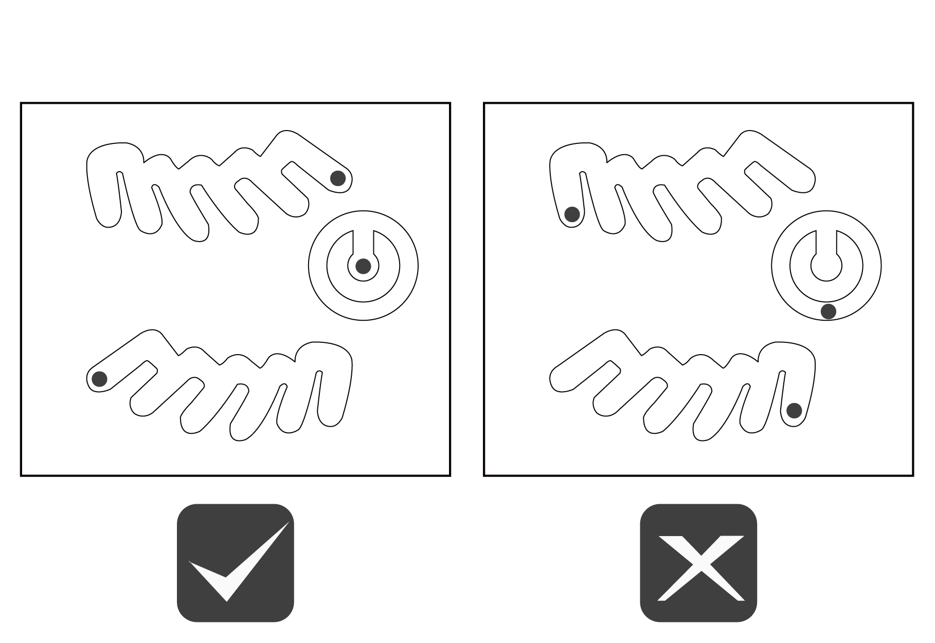

Figure ‑ Tilt and Inversion Indicators

* If the shock watch appears red, contact Autel customer service and the delivery personnel, and then inspect the product for any damage.

1. Remove the packaging material and interior protection materials using appropriate tools.
2. Inspect whether the MaxiCharger and the parts for installation are damaged. If any damage is found or the parts are not consistent with the order, contact your local dealer.
3. Make sure that all parts are delivered according to the order.

## Moving the Cabinet to the Site

There are two ways to move the cabinet to the installation site:

* Hoist
* Forklift

WARNING

* Follow the safety instructions that apply to the hoisting equipment or forklift to move the cabinet.
* Take into account the dimensions, mass, and center of gravity of the MaxiCharger.

CAUTION

* DO NOT drop the cabinet or subject it to strong impact.
* DO NOT exceed a tilting angle of 30°.
* Avoid excessive force on the hoisting points.

### **Hoisting the Cabinet**

* To hoist the cabinet

1. Install the four eyebolts (M16) to the lifting holes (A).
2. Connect the cables of the hoisting equipment to the eyebolts or bolts with lifting loops.
3. 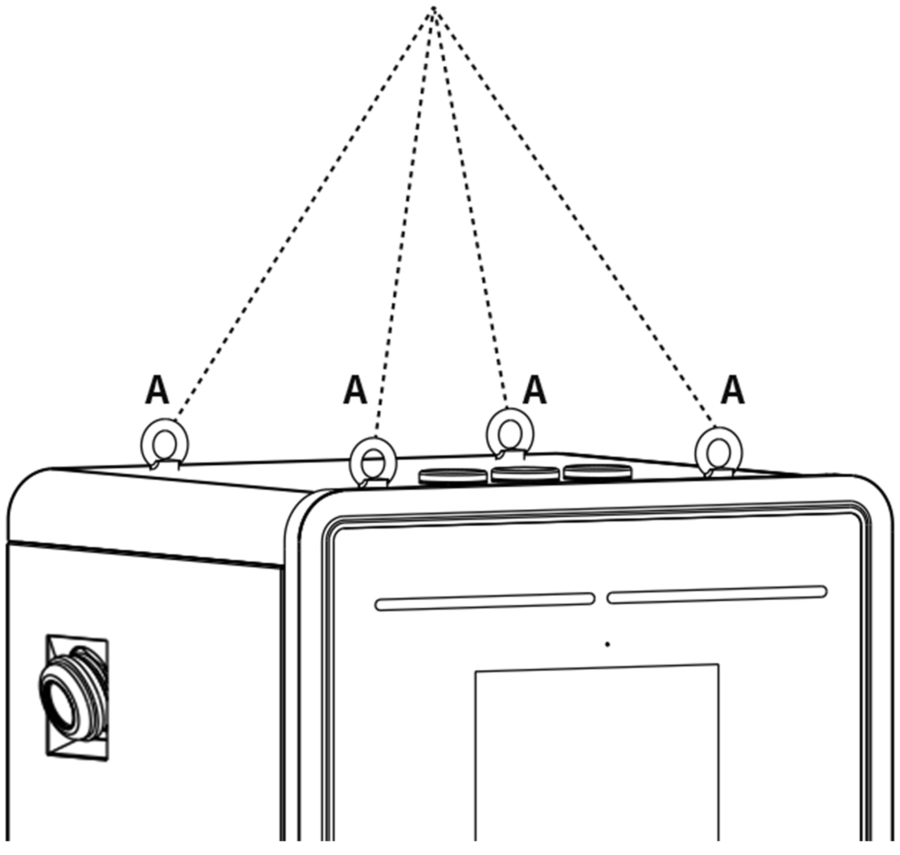Move the cabinet to the construction site.

Figure ‑ Hoisting the Cabinet

### Forklifting the Cabinet

* To forklift the cabinet

1. Make sure the forks (A) of the forklift truck in the gaps go through the gaps in the side of the pallet.
2. 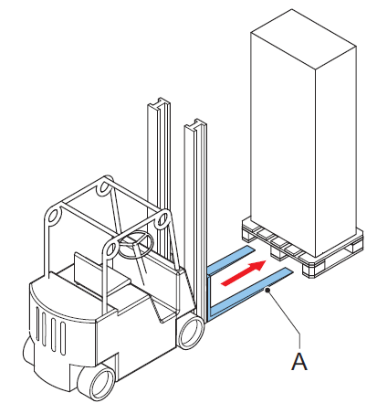Move the cabinet to the construction site.

***Figure 4‑3 Transporting*** the Cabinet by Forklift

## Packing List

Table ‑ Packing List

|  |  |  |  |
| --- | --- | --- | --- |
| **MaxiCharger** |  | **Expansion Bolt** (M16 x 150)  4 PCS |  |
| **Washer** (10)  5 PCS  (for 120 kW only) |  | **Washer** (10)  10 PCS  (for 240 kW only) |  |
| **Hexagonal Nut** (M10)  5 PCS |  | **Spring Washer** (10)  5 PCS  (for 240 kW only) |  |
| **Bolt** (M8 x 25)  2 PCS |  | **Packing List** |  |
| **Eye Bolt** (M16)  4 PCS |  | **Cabinet Door Key**  2 PCS | C:\Users\A21252\Desktop\On-going\20220421-120kW欧标直流桩\图片\钥匙_画板 1(1).jpg |
| **Bolt** (M10 x 30)  5 PCS  (for 120 kW only) |  | **Bolt** (M10 x 35)  5 PCS  (for 240 kW only) |  |
| **Screw (M4 x 10)**  24 PCS  (for 120 kW only) |  | **Screw (M4 x 10)**  48 PCS  (for 240 kW only) |  |
| **Drilling Template**  (for 120 kW only) |  | **Drilling Template**  (for 240 kW only) |  |

## Installation Tools

Table ‑ Installation Tools

| Tool | Specification |
| --- | --- |
| **Philips Screwdriver** | Size: PH2 |
| **Slot Screwdriver** | Size: 2.5 and 4.5 |
| **Open Spanner** | * M8 (13 mm) * M10 (15 mm) * M16 (24 mm) |
| **Ratchet Spanner with**  **Socket and Extension** | * M8 (13 mm) * M10 (15 mm) * M16 (24 mm) |
| **Voltage Tester** | Standard |
| **Digital Multimeter** | Standard |
| **Hoisting Equipment or**  **Forklift** | Capable to lift the MaxiCharger safely. Refer to different specifications in Technical Specifications. |
| **Wire Stripper Tool** | To strip the wires of the AC input cable. |
| **Cable Lug Tools** | Size: M10 (AC wires) |

NOTE

* The tools mentioned above are not provided. Be sure to have all the tools prepared prior to the installation.
* This tool list does not necessarily include all the tools you may need.

# Installation

IMPORTANT

* The installation should be performed by an installation engineer.
* Make sure all required permits are granted form local authorities.
* Make sure the AC input cable is available.
* Make sure the tools for installation are prepared, see Table 4‑2 Installation Tools.
* Check the cable connection status and voltages before powering on the MaxiCharger.
* Make sure there is no voltage on the AC input cable during the entire installation procedure.
* To perform an installation (general procedure)

1. Prepare the site and unpack the MaxiCharger.
2. Install the cabinet.
3. Prepare for cable installation.
4. Connect the electrical wires.
5. Install the charging modules.
6. Install the external residual-current device.
7. Prepare for commissioning.

## Preparing the Installation Site



An installation site design is a prerequisite for determining conduit and wiring requirements from the panel to proposed parking spaces, as well as for measuring cellular signal strength and identifying suitable locations for any necessary cellular signal booster equipment.

IMPORTANT

Always check local codes or consult an engineer to ensure the site is prepared in accordance with all applicable regulations. Local authorities might not allow a unit to operate if it is not installed to code.

* To prepare an installation site (general procedure)

1. Make sure the site meets the requirements, see Location Requirements.
2. Prepare an external residual-current device if required by local rules, see Installing the External Residual-current Device.
3. Prepare the cables, including the AC input wire, PE wire, and Ethernet cable (if no cellular network is available).

NOTE

* To use an Ethernet cable, ensure the Internet connection is available for an approved service engineer and the network operating center of the manufacturer.
* The cables enter the cabinet from the bottom or the rear side of the base.
* Consider the maximum diameter of the cable inlet when you prepare the cables.

1. Make sure that the cable slack is sufficient to guide the cables in the cabinet.
2. Prepare the foundation for the cabinet.

### Location Requirements

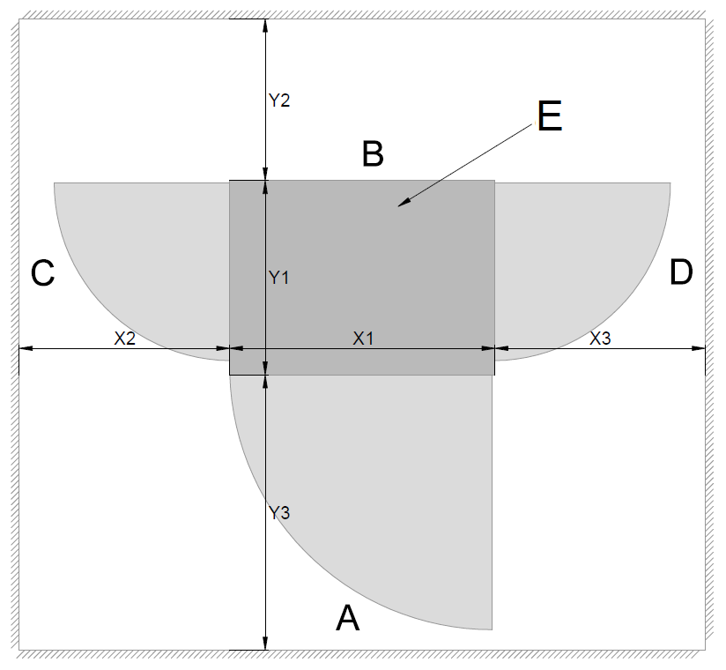An installation space of 2420 x 1950 mm (for MaxiCharger DF120) or 2620 x 2050 mm (for MaxiCharger DF240) is required in order to ensure normal operation and proper airflow around the unit. The space is calculated as follows:

Figure ‑ Location Requirements

A. Front side of the MaxiCharger

B. Rear side of the MaxiCharger

C. Left side of the MaxiCharger

D. Right side of the MaxiCharger

E. Cabinet

Table ‑ Location Requirements (for MaxiCharger DF120)

| Parameter | Specification | |
| --- | --- | --- |
| mm | in |
| **X1** | 820 | 32.28 |
| **X2** | 800 | 31.5 |
| **X3** | 800 | 31.5 |
| **Y1** | 600 | 23.62 |
| **Y2** | 500 | 19.69 |
| **Y3** | 850 | 33.46 |

Table ‑ Location Requirements (for MaxiCharger DF240)

| Parameter | Specification | |
| --- | --- | --- |
| mm | in |
| **X1** | 820 | 32.28 |
| **X2** | 900 | 35.43 |
| **X3** | 900 | 35.43 |
| **Y1** | 700 | 27.56 |
| **Y2** | 500 | 19.69 |
| **Y3** | 850 | 33.46 |

* Choose a site where the charging cable is of sufficient length to be connected to the EV charge port. The standard length of the charging cable is 4 meters, but a 7.5-meter cable is also available.
* Take into account the limited reach of a wheelchair user.
* Determine appropriate ground anchoring locations where concrete exists or can be installed (no asphalt surfaces).
* Consider locations where it will be easy to add future stations.
* Determine optimum conduit layout to minimize linear conduit costs to multiple parking spaces. If possible, avoid or minimize trenching requirements.
* Evaluate existing electrical infrastructure to determine if the existing utility service and electrical panel capacity is sufficient. Identify costs for any necessary upgrades and/or a new dedicated electrical panel. We recommend you invite a certified electrician to evaluate available capacity and identify any upgrades that may be required.
* If a dedicated EV electrical panel is required, choose a panel location in close proximity to the existing electrical supply.
* Measure cellular signal strength to ensure adequate cellular coverage at the installation site. To ensure adequate signal strength in underground or enclosed parking structures, cellular repeaters may be required.
* We recommend you avoid locations under trees where sap, pollen or leaves would fall on the MaxiCharger and increase the station owner’s site upkeep workload.
* For stall parking, we recommend you use perpendicular parking stalls that allow a vehicle to enter either front-first or rear-first, to better accommodate the varied charge port locations on different EVs. Diagonal stall parking is not advised.

NOTE

While Autel tests the MaxiCharger with a majority of modern vehicles, we cannot guarantee the port locations of future vehicles and cannot warrant the configurations proposed will work for all vehicles.

* Choose adjacent parking spaces in an area with adequate lighting.
* Consider how easily drivers can find the stations they need to access.
* Check local requirements for accessibility and pathway width, sometimes called "path of travel", to ensure station placement does not restrict sidewalk use.

IMPORTANT

Place each MaxiCharger centered at the head of its parking space, with the touchscreen facing the vehicle. This placement maximizes cable reach for the varied charge port locations on different EVs.

* Pull-through parking (gas station model) is not recommended.

### Preparing the Foundation

* To prepare a casted foundation

1. Dig a hole based on the foundation size.

IMPORTANT

* The minimum sizes of the hole for MaxiCharger DF120 and MaxiCharger DF240 are 820 x 640 x 500 mm and 820 x 740 x 500 mm, respectively.
* The foundation must meet the C30 requirements.

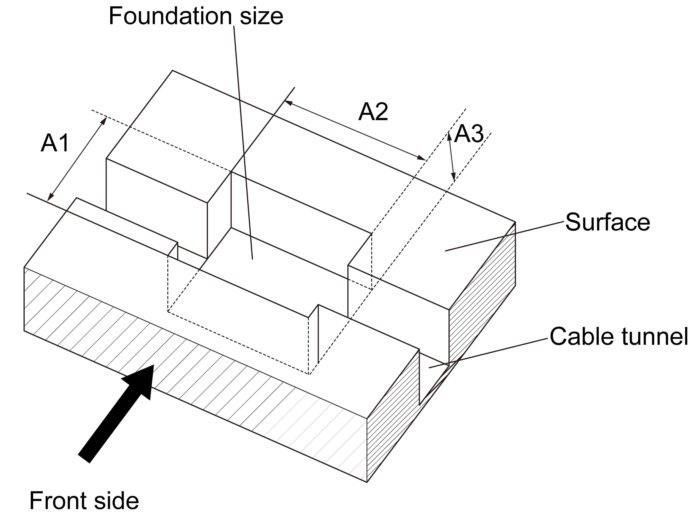

Figure ‑ Digging a Hole

Table ‑ Digging a Hole Specifications

| Parameter | Specification | | | |
| --- | --- | --- | --- | --- |
| MaxiCharger DF120 | | MaxiCharger DF240 | |
| **A1** | 640 mm | 25.2 in | 740 mm | 29.13 in |
| **A2** | 820 mm | 32.28 in | 820 mm | 32.28 in |
| **A3** | 500 mm | 19.68 in | 500 mm | 19.68 in |

1. Pour the concrete into the hole. Make sure that the cable duct/conduit is in the correct position. Ensure that the conduit come out of the surface within the marked area (C). See *Figure 5‑4 Drilling Holes* and *Table 5‑6 Drilling Holes Specifications*.

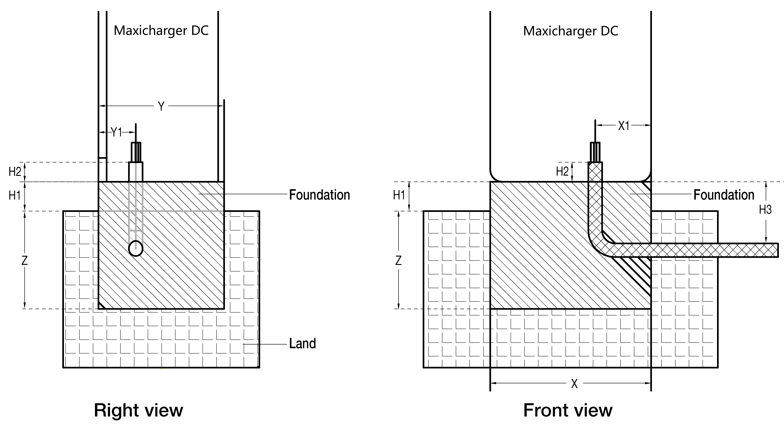

Figure ‑ Pouring the Concrete and Setting the Conduit

Table ‑ Foundation Specifications

| Parameter | Specification | | | |
| --- | --- | --- | --- | --- |
| MaxiCharger DF120 | | MaxiCharger DF240 | |
| **X** | 820 mm | 32.28 in | 820 mm | 32.28 in |
| **X1** | 285 mm | 11.22 in | 275 mm | 10.83 in |
| **Y** | 640 mm | 25.2 in | 740 mm | 29.13 in |
| **Y1** | 190 mm | 7.48 in | 151 mm | 5.94 in |
| **Z** | 500 mm | 19.69 in | 500 mm | 19.69 in |
| **H1** | 150 mm | 5.9 in | 150 mm | 5.9 in |
| **H2** | 100 mm | 3.94 in | 100 mm | 3.94 in |
| **H3** | 350 mm | 13.78 in | 350 mm | 13.78 in |

NOTE

* Make sure the angle and diameter of the conduit meet the requirements for wires to be guided through.
* Make sure the size of the marked area (C) meets the specifications shown in *Table 5‑6 Drilling Holes Specifications*. The area (C) is marked in *Figure 5‑4 Drilling Holes*.

IMPORTANT

The foundation needs to be 150 mm above the surface.

1. Let the concrete dry.
2. Pull the wires through the conduit. Apply the cable slack according to the following specifications.

Table ‑ Cable Slack Specifications

| Parameter | Specification | |
| --- | --- | --- |
| mm | in |
| **Required Cable Slack for the Ethernet Cable (Measured from the Top of the Foundation)** | 750 | 29.53 |
| **Required Cable Slack for the AC Input Cable (Measured from the Top of the Foundation)** | 600 | 23.62 |

1. Place the drilling template provided in the package onto the foundation, aligning with the marked area (C). Mark the four drilling holes (D) and remove the drilling template.
2. Drill four holes with over 110 mm in depth and 20 mm in diameter in the foundation at the marked positions (D) for inserting the expansion bolts into the holes. Clean the drilling ashes.

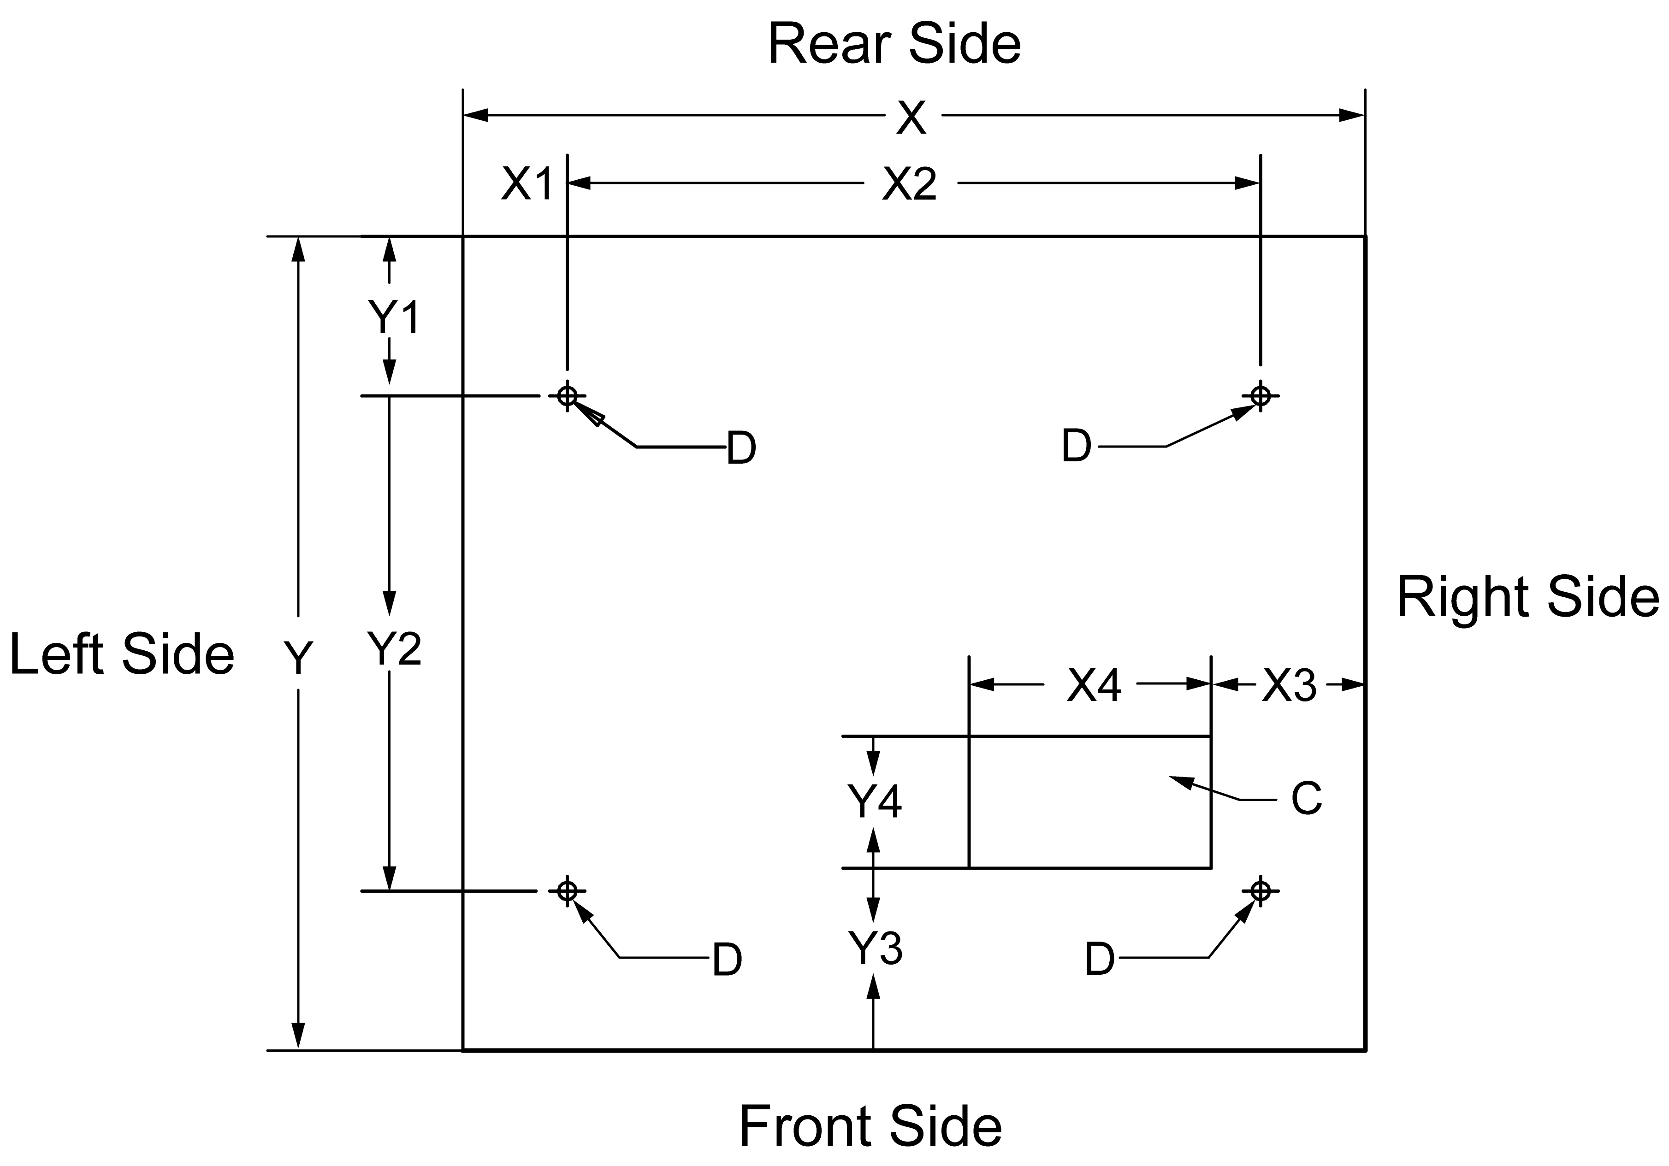

***For MaxiCharger DF120***

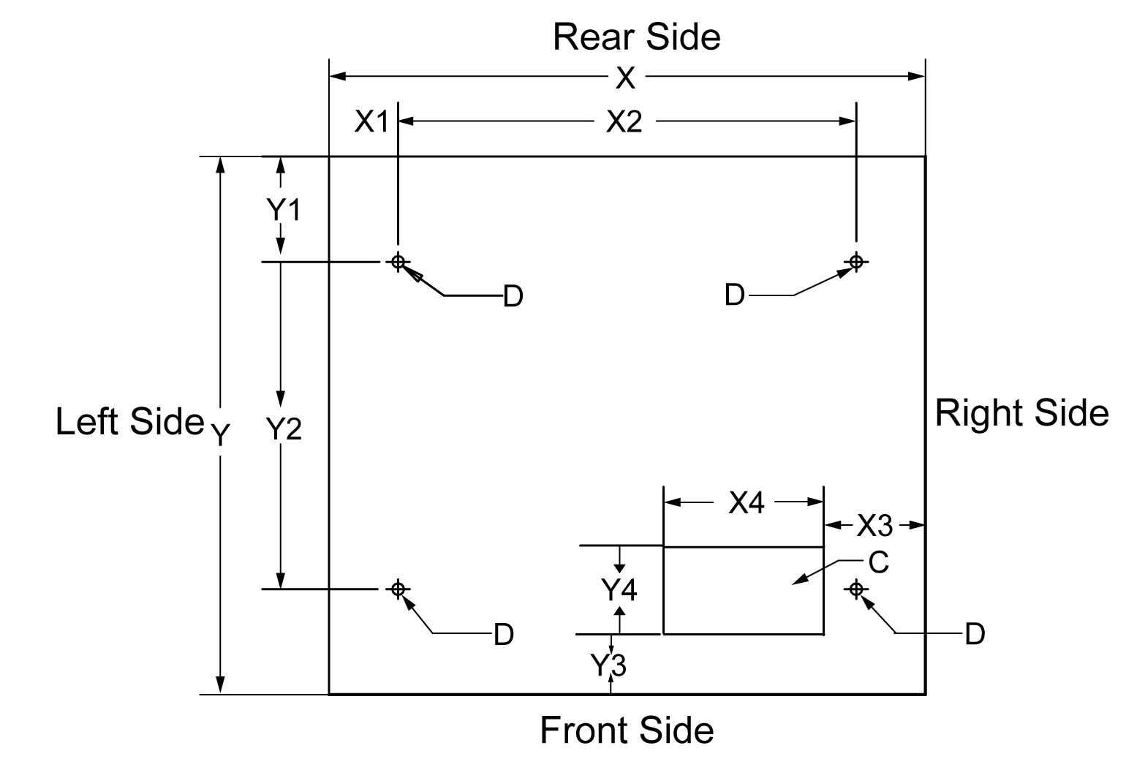

***For MaxiCharger DF240***

Figure ‑ Drilling Holes

Table ‑ Drilling Holes Specifications

| **Parameter** | **Specification** | | | |
| --- | --- | --- | --- | --- |
| **MaxiCharger DF120** | | **MaxiCharger DF240** | |
| **X** | 820 mm | 32.28 in | 820 mm | 32.28 in |
| **X1** | 95 mm | 3.74 in | 95 mm | 3.74 in |
| **X2** | 630 mm | 24.80 in | 630 mm | 24.80 in |
| **X3** | 132 mm | 5.51 in | 140 mm | 5.51 in |
| **X4** | 220 mm | 8.66 in | 220 mm | 8.66 in |
| **Y** | 640 mm | 25.20 in | 740 mm | 29.13 in |
| **Y1** | 94.3 mm | 3.71 in | 144.3 mm | 5.68 in |
| **Y2** | 450 mm | 17.72 in | 450 mm | 17.72 in |
| **Y3** | 131 mm | 5.16 in | 91.5 mm | 3.60 in |
| **Y4** | 120 mm | 4.72 in | 120 mm | 4.72 in |

1. Tap four expansion bolts (M16 x 150) in the drilled positions (D) on the foundation. The expansion bolts needs to be 60 mm above the foundation.

## Installing the Cabinet

* To install the cabinet

1. 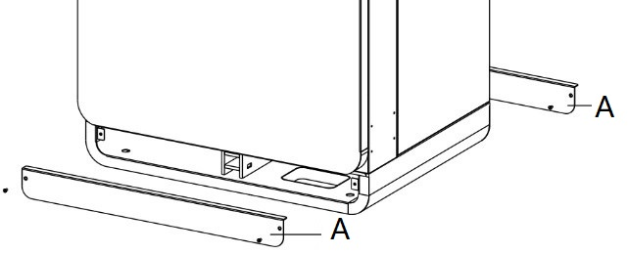Remove the front and rear base covers (A) using a screwdriver.

Figure ‑ Removing the Base Covers

1. 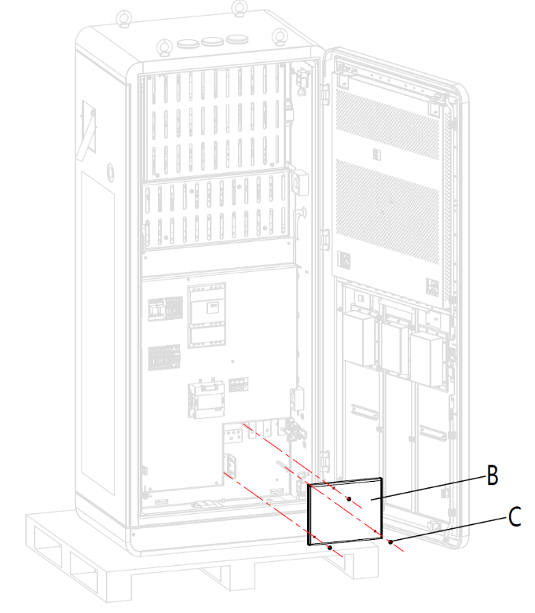Open the front door of the cabinet. Remove the M6 screws (C) and the insulating barrier (B) from the cabinet. (Reinstall the insulating barrier when the commissioning procedure is complete.)

Figure ‑ Removing the Insulating Barrier

1. 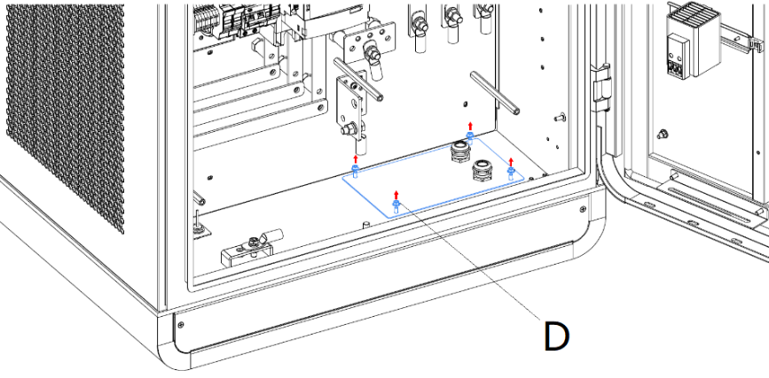Loosen the fasteners (D) on the cable gland plate to remove the plate and close the door.

Figure ‑ Loosening the Fasteners

1. Remove the hexagonal nuts (E), spring washers (F), washers (G1), bolt (H), and washers (G2).

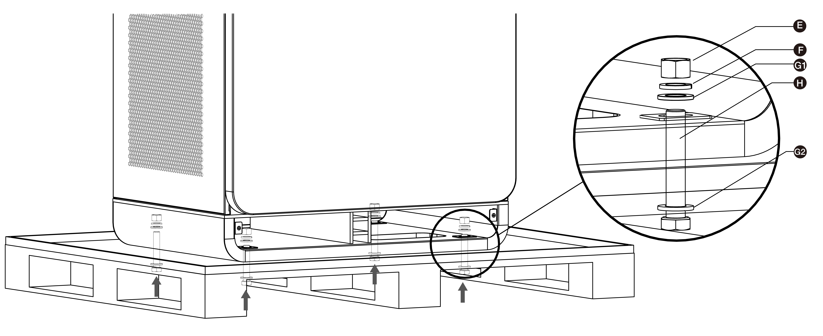

Figure 5‑8 Removing the Cabinet from the Pallet

1. Discard the pallet.
2. Lift the cabinet with the hoisting equipment at 500 mm (19.69") above the foundation. Pull all the cables out of the foundation and guide the cables through the base of the cabinet.
3. Carefully lower the cabinet on the foundation. Make sure that the cabinet is aligned with the installation holes.
4. Remove the eyebolts (M16) on the top of the cabinet and seal the holes.
5. 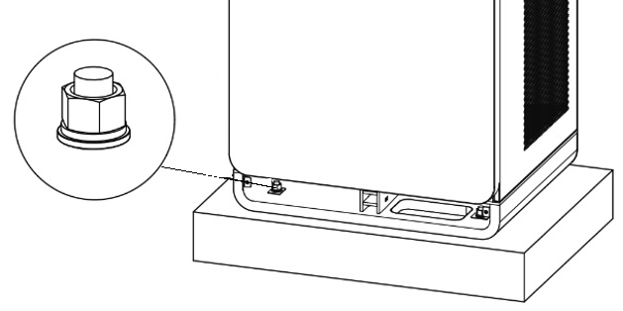Tighten the bolts.

Figure 5‑9 Tightening the Bolts

## Preparing for Electrical Cable Installation

* To prepare for cable installation

1. Reinstall the cable gland plate.

CAUTION

If the cable gland for the Ethernet cable is not used, make sure that the cable gland is closed and sealed.

1. Guide the AC input wires (C) and Ethernet cables (E) through the cable gland plate as instructed in the following figure and tighten the four fasteners to secure the cable gland plate.

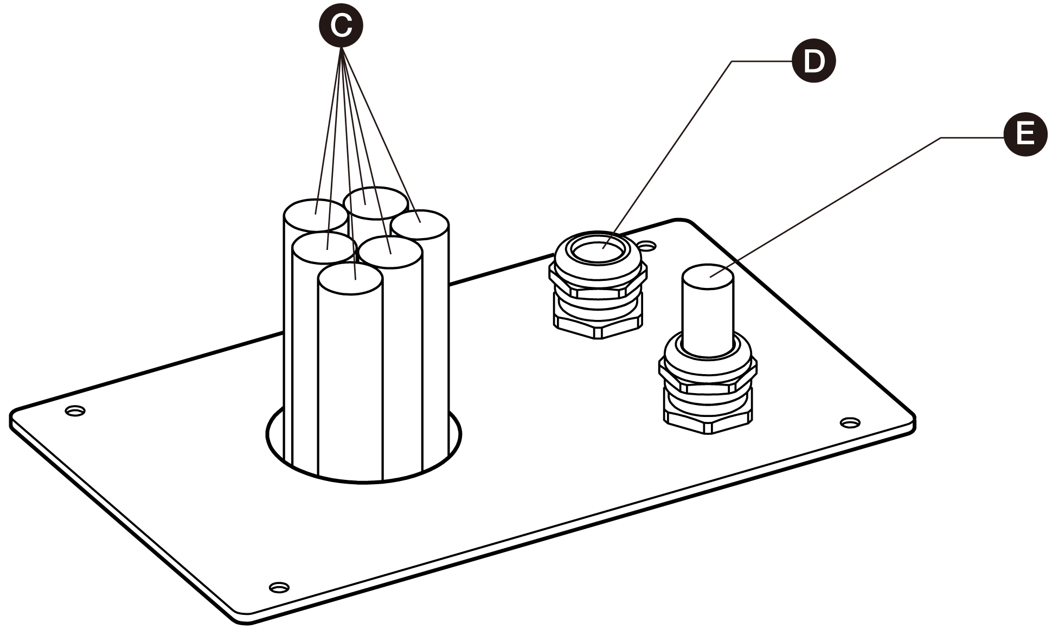

Figure ‑ Guiding the Cables through the Cable Gland Plate

CAUTION

* If it is necessary, install the cable gland over the Ethernet cable.
* The cable gland (D) is optional.

## Electrical Wiring

### Connecting the PE Wire

* To connect the PE wire

1. Cut the PE wire (C) of the power cable to the correct length to reach the PE busbar (B).
2. Use the wire stripper to remove 20 mm of the insulation from the end of the wires (or strip the wire if necessary). Make sure that the strip length is compatible with the cable lug (A).
3. Use the crimping tool to attach the cable lug to the end of the wire.
4. Use the fasteners (D) to attach the PE wire to the PE busbar.
5. 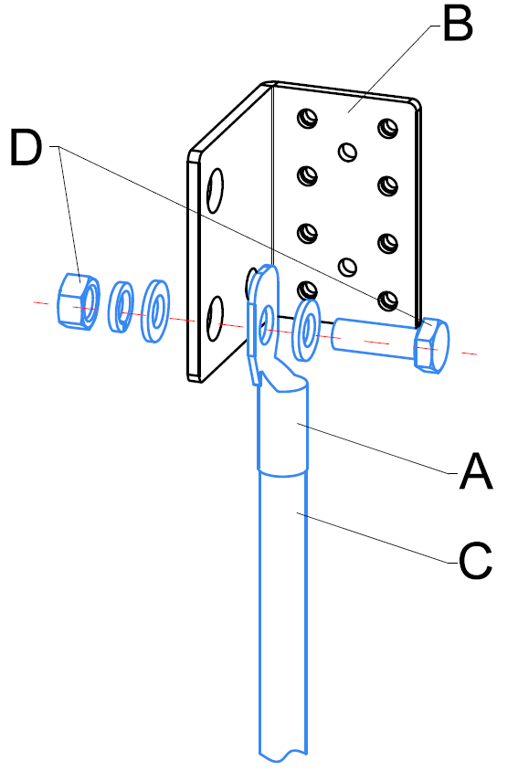Tighten the fasteners to the correct torque.

Figure 5‑11 PE Wire Connection

NOTE

We recommend to use the torque 20.5 ± 2.5 Nm.

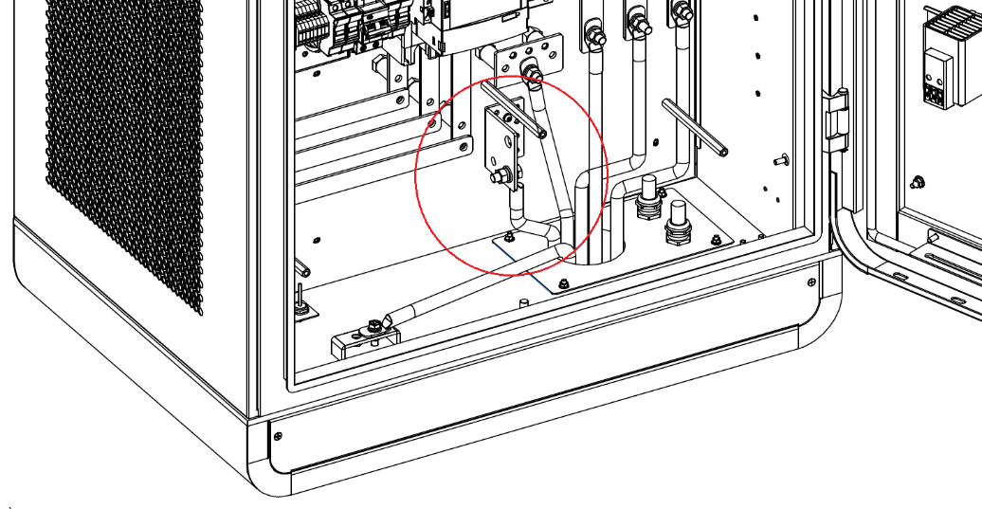

Figure 5‑12 Connecting the PE Wire

### Connecting the Enclosure to the earth

* To connect the enclosure to the earth

1. Connect the earthing conductor to the pin of the enclosure.
2. 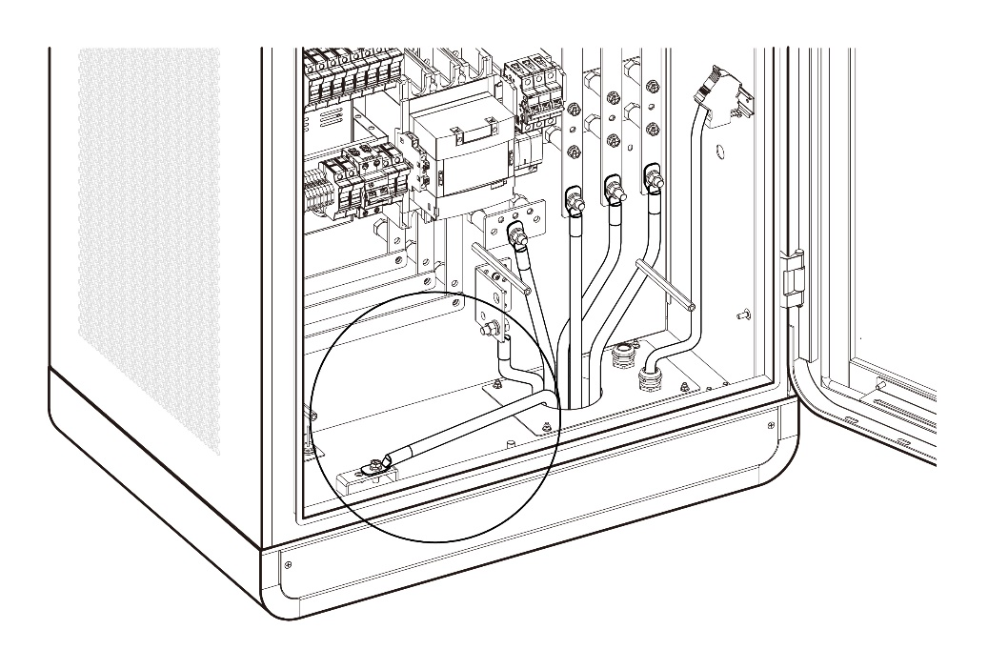Connect the earthing conductor to the earthing electrode.

Figure 5‑13 Connecting the Enclosure to the earth

### Connecting the AC Input Wires

* To connect the AC input wires

1. Cut the wires N, L1, L2, and L3 to the correct length to reach the connectors on the AC fuse copper busbar.
2. Use the wire stripper to remove 20 mm of the insulation from the end of the wires (or strip the wire if necessary). Make sure that the strip length is compatible with the cable lugs.
3. Use the crimping tool to attach the cable lugs to the end of the wires.
4. Use the fasteners to attach the wires to the connectors:

* L1 wire to the connector A
* L2 wire to the connector B
* L3 wire to the connector C
* N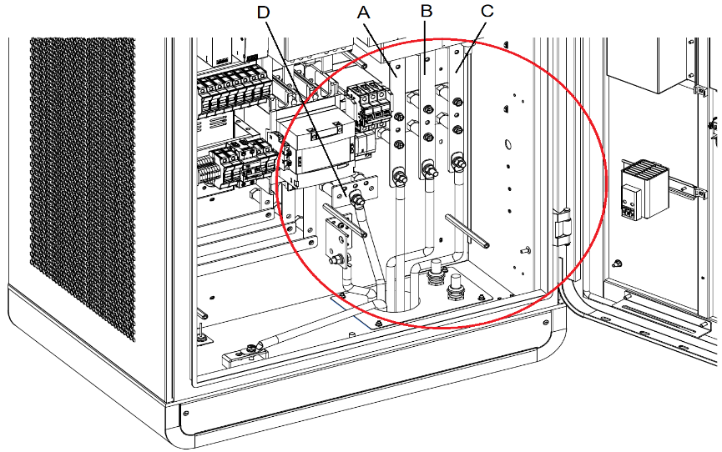 wire to the connector D

Figure 5‑14 Connecting the AC Input Wires

1. Tighten the fasteners to the correct torque.

NOTE

* We recommend to use the torque 20.5 ± 2.5 Nm.
* Required cable slack for the AC input cable (measured from the top of the foundation) is 600 mm (23.62").

1. Use cable ties to bundle the wires in two or three places.
2. If the conduit opening was not sealed as part of the site preparation process, seal it using duct seal.

If needed, connect two AC input wires of the same type to each connector as shown below:

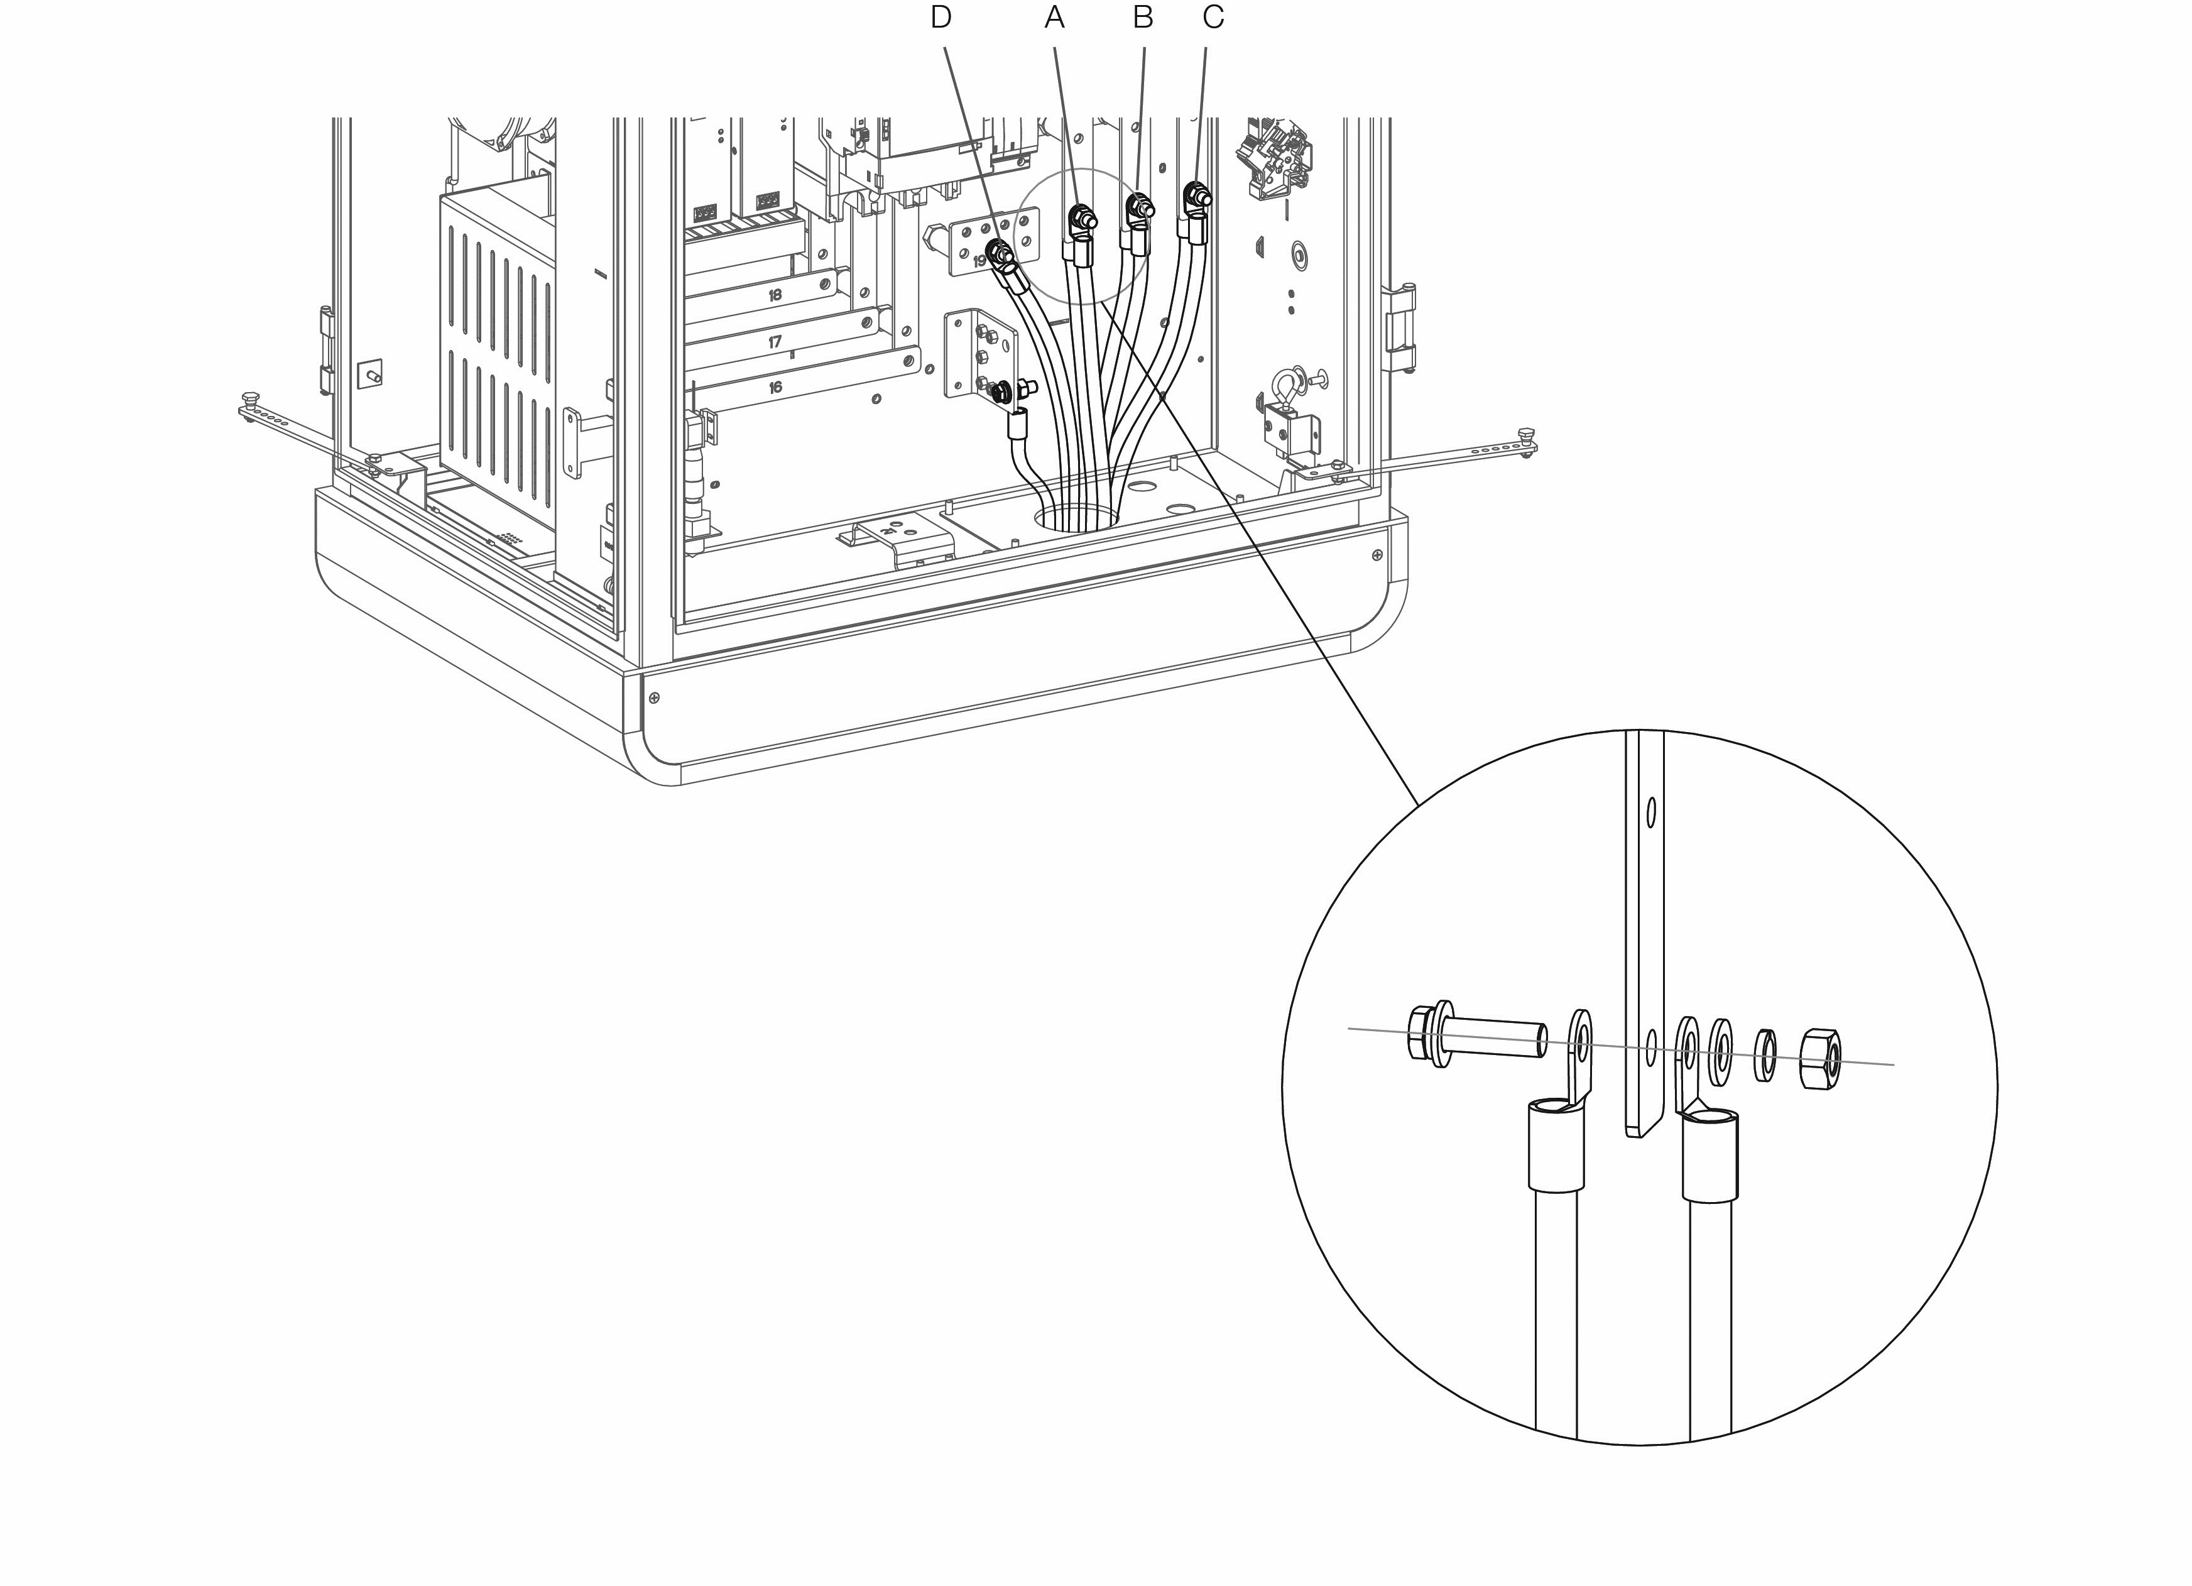

Figure 5‑15 Connecting the Two AC Input Wires

### Connecting the Ethernet Cable

Connect the Ethernet cable to one of the RJ45 ports.

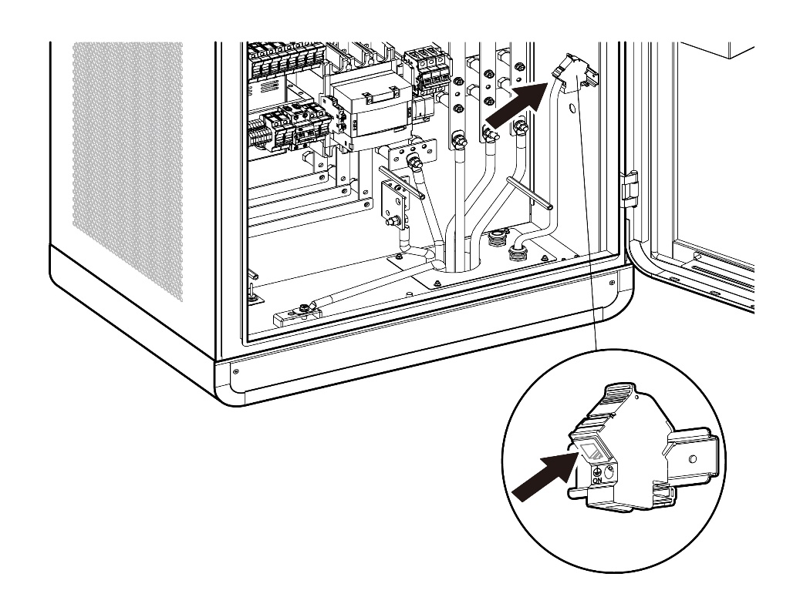

Figure 5‑16 Connecting the Ethernet Cable

### Installing SIM Card

1. Press the button (A) to eject the SIM card tray.
2. Insert the SIM card into the tray. Ensure the card is placed correctly.
3. Push the card tray into the slot.

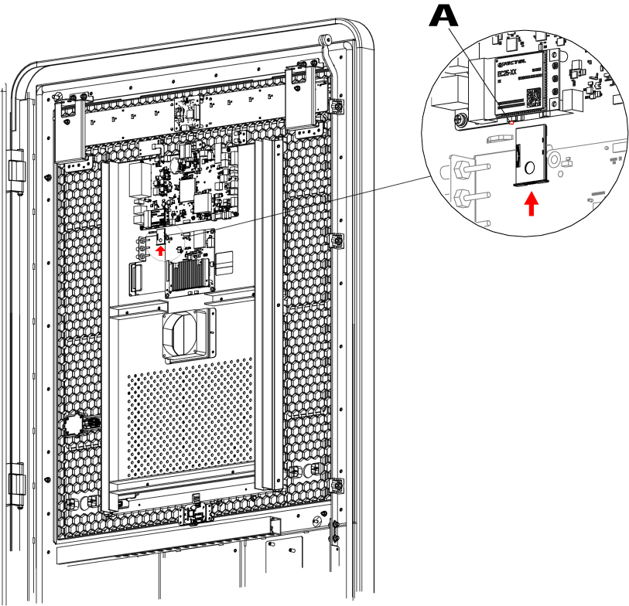

Figure 5‑17 Installing SIM Card

## Installing the Charging Modules

NOTE

The illustraions below are for reference only. Install the charging modules based on the location number on the cabinet.

* To install the charging modules

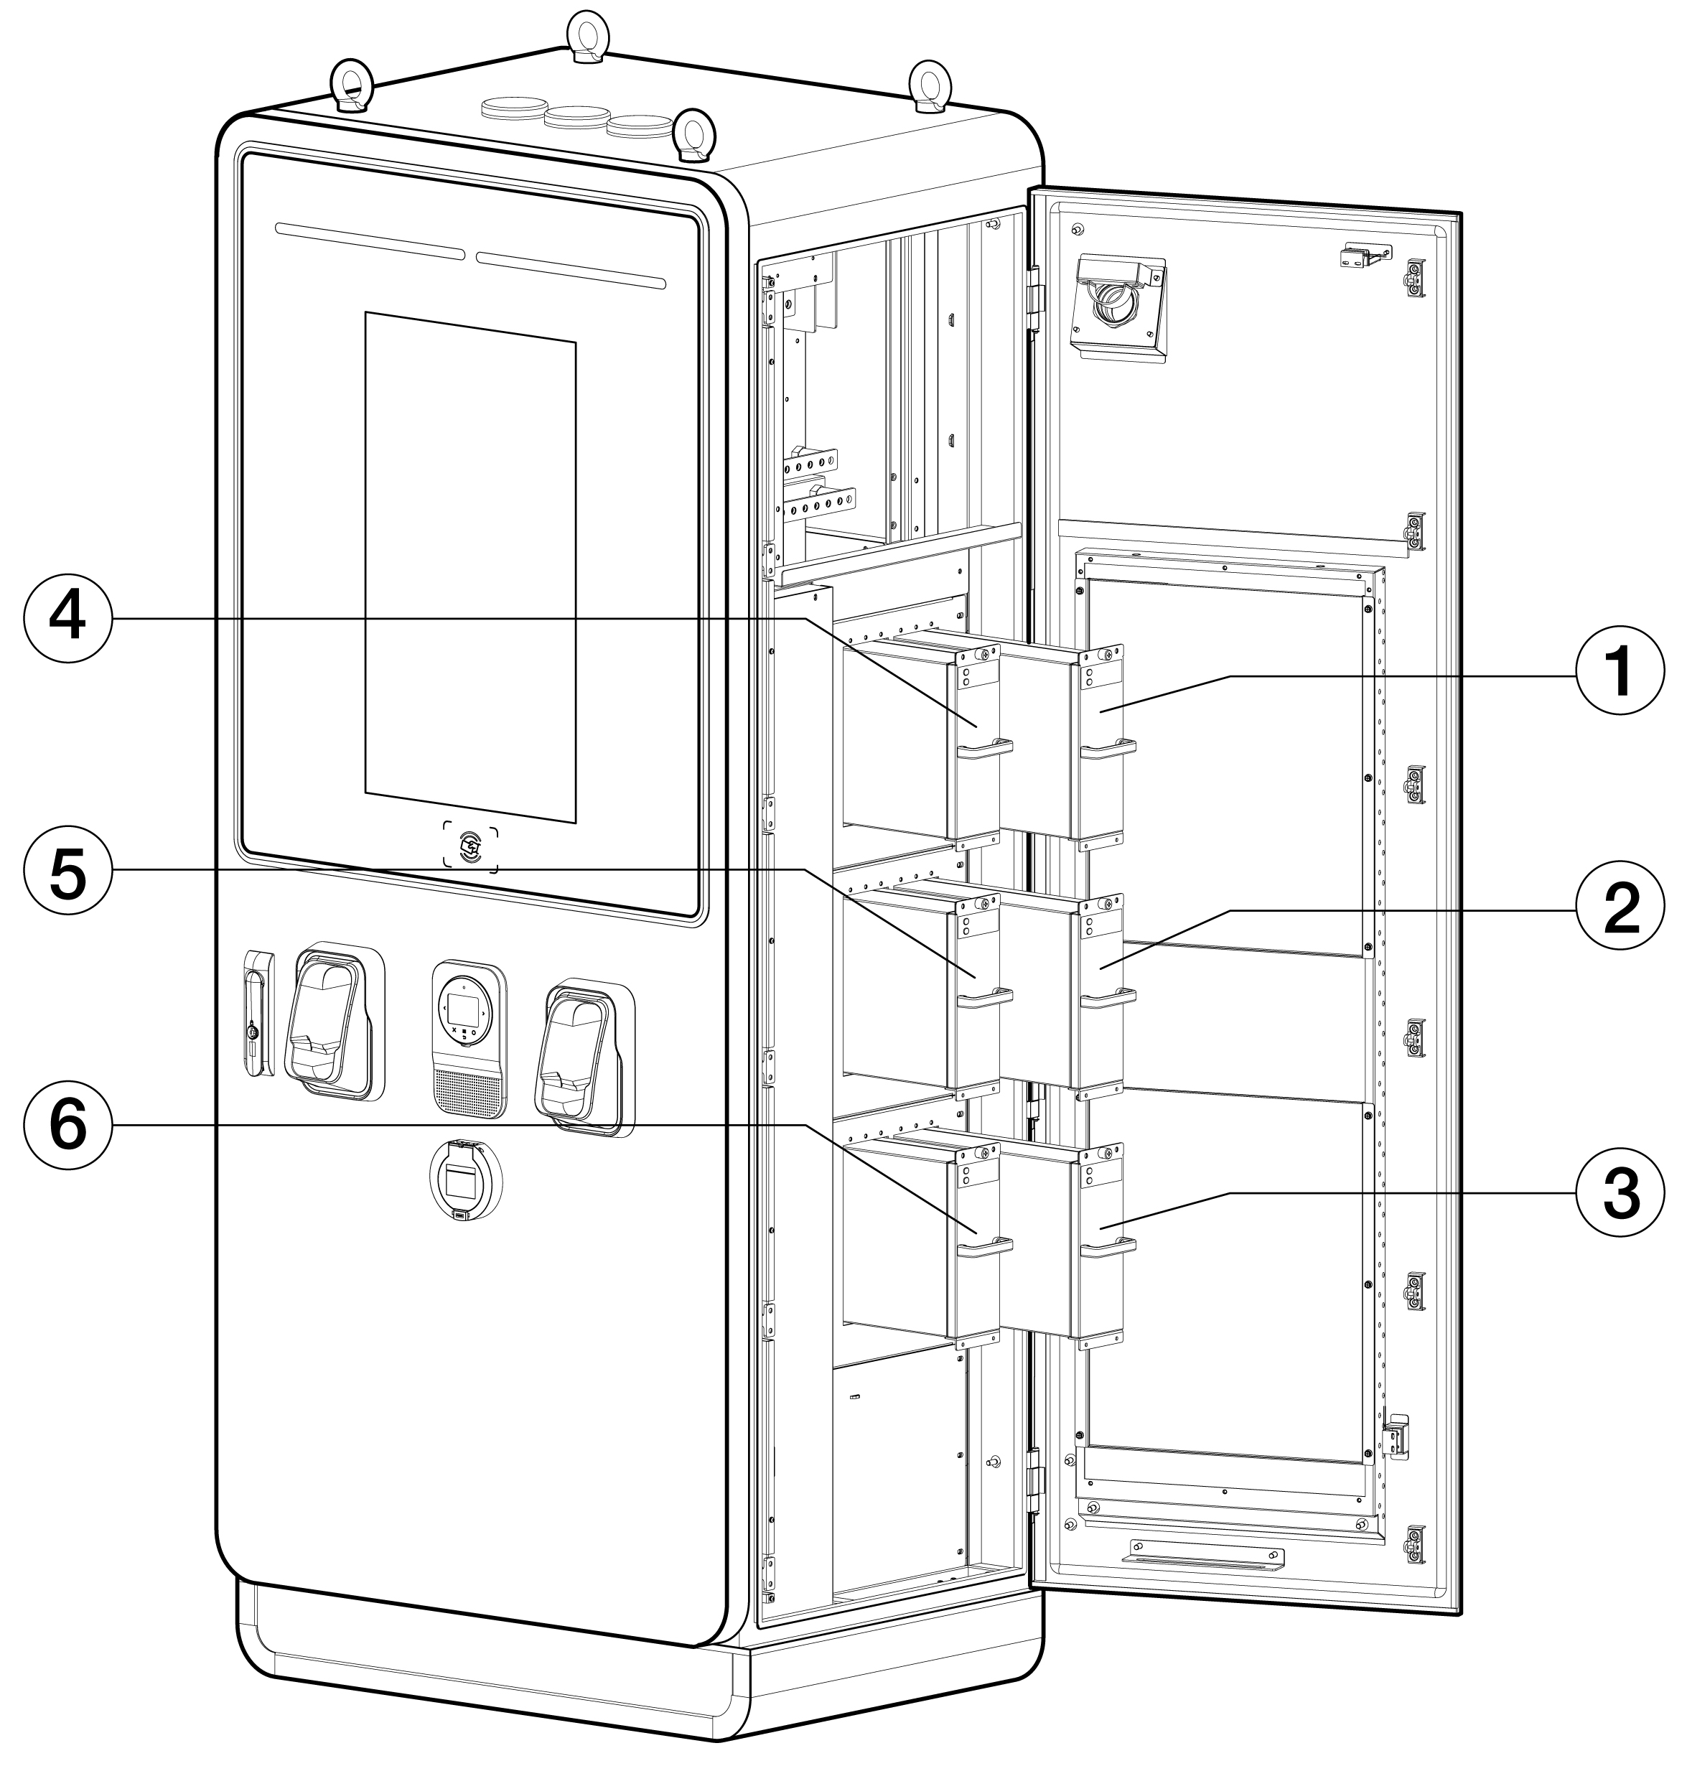

Figure 5‑18 Installing the Charging Modules (for MaxiCharger DF120)

1. Slowly push the module into the slot.

Table ‑ Charging Module Installation Specifications (for MaxiCharger DF120)

| Type | Rated Power | Number of Modules | Location |
| --- | --- | --- | --- |
| **MaxiCharger DF40**  (EF040A2001/EF040C2001) | 40 kW | 2 PCS | 1, 4 |
| **MaxiCharger DF60**  (EF060A3001/EF060C3001) | 60 kW | 3 PCS | 1, 2, 4 |
| **MaxiCharger DF80**  (EF080A3001/EF080C3001) | 80 kW | 4 PCS | 1, 2, 4, 5 |
| **MaxiCharger DF100**  (EF100A3001/EF100C3001) | 100 kW | 5 PCS | 1, 2, 3, 4, 5 |
| **MaxiCharger DF120**  (EF120A3001/EF120C3001) | 120 kW | 6 PCS | 1, 2, 3, 4, 5, 6 |

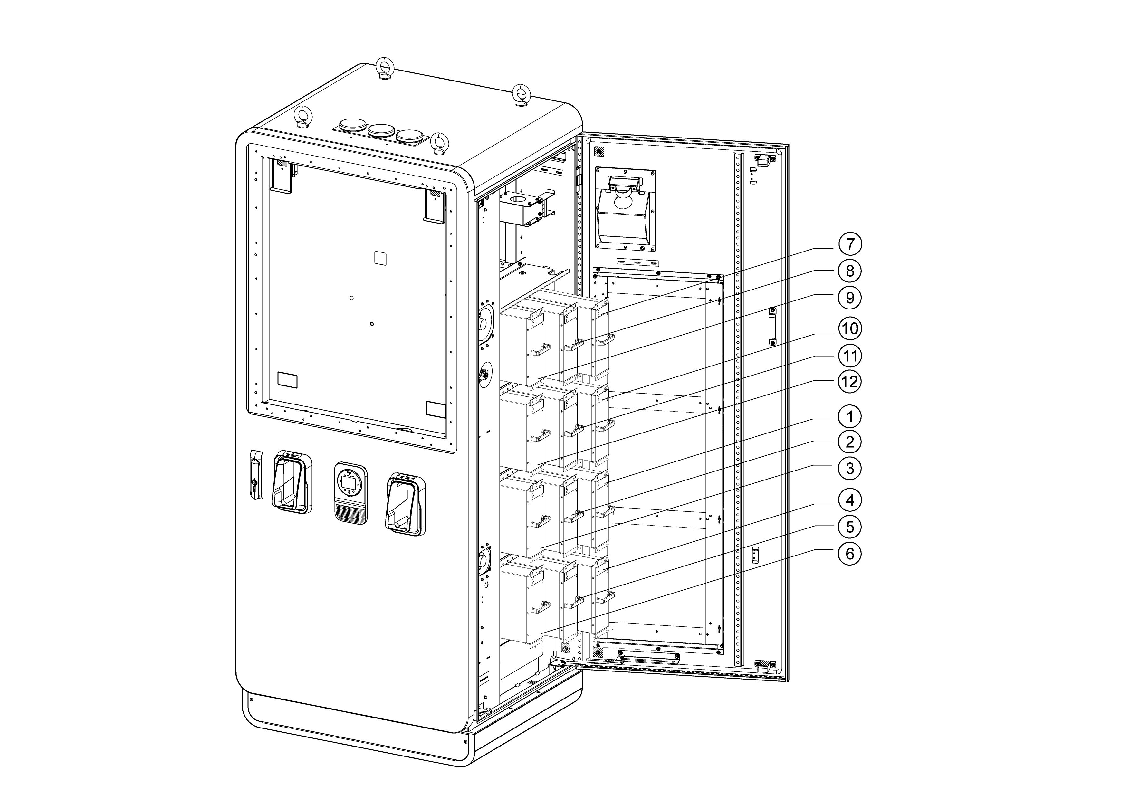

Figure 5‑19 Installing the Charging Modules (for MaxiCharger DF240)

Table 5‑8 Charging Module Installation Specifications (for MaxiCharger DF240)

| Type | Rated Power | Number of Modules | Location |
| --- | --- | --- | --- |
| **MaxiCharger DF160**  (EF160A3001) | 160 kW | 8 PCS | 1, 2, 3, 4, 7, 8, 9, 10 |
| **MaxiCharger DF180**  (EF180A3001) | 180 kW | 9 PCS | 1, 2, 3, 4, 5, 7, 8, 9, 10 |
| **MaxiCharger DF200**  (EF200A3001) | 200 kW | 10 PCS | 1, 2, 3, 4, 5, 7, 8, 9, 10, 11 |
| **MaxiCharger DF220**  (EF220A3001) | 220 kW | 11 PCS | 1, 2, 3, 4, 5, 6, 7, 8, 9, 10, 11 |
| **MaxiCharger DF240**  (EF240A3001) | 240 kW | 12 PCS | 1, 2, 3, 4, 5, 6, 7, 8, 9, 10, 11, 12 |

IMPORTANT

Install the sealing boards into the slots where the charging modules are not inserted.

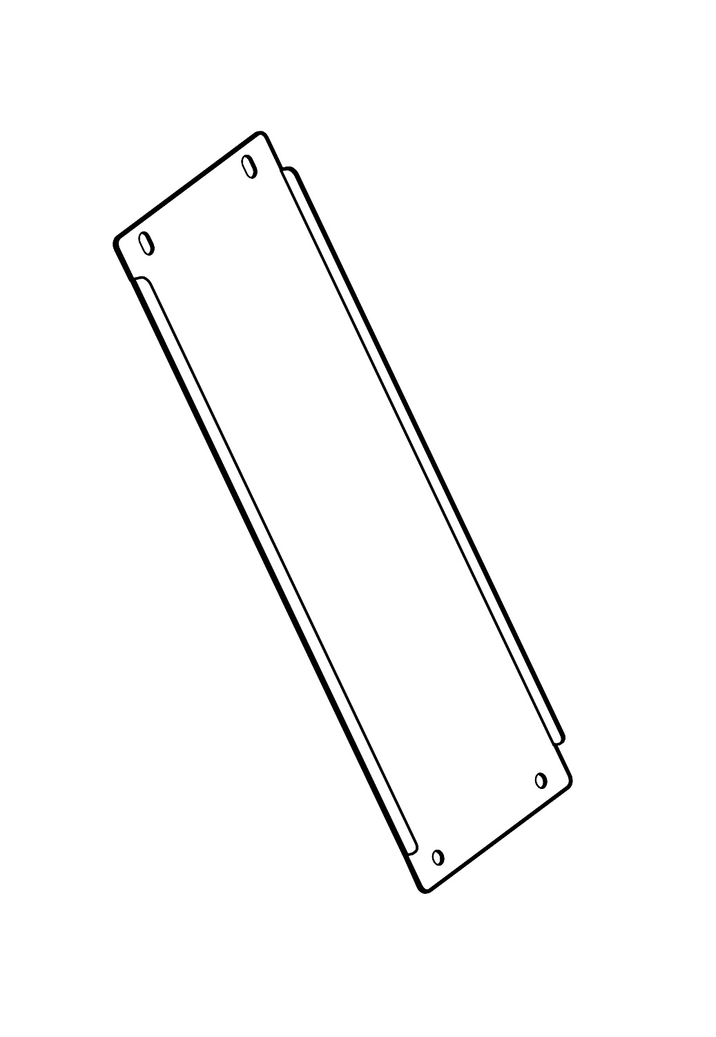

Figure ‑ Sealing Board

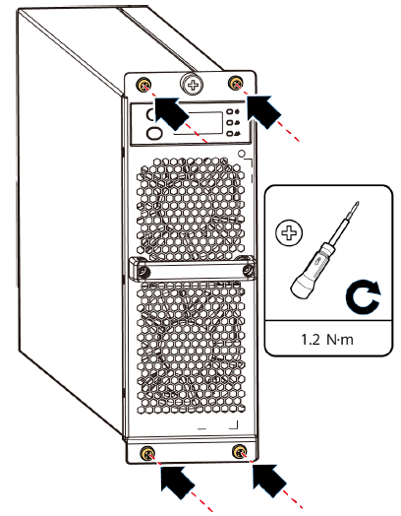

Figure ‑ Tightening the Screws

1. Tightening the screws to the torque of 1.2 Nm to secure the modules.
2. After the installation is complete, set the hardware address. For details, contact manufacturer certified installation engineer.
3. Seal the cable holes of the cabinet and close the doors.

## Installing the External Residual-current Device

The MaxiCharger includes a Type A RCD integrated in the main breaker, and a RCCB for the auxiliary path.

The use of external RCD may cause a nuisance tripping during transient conditions such as when the AC contactor turns on at the start of charging. If an external residual-current device cannot be avoided due to local regulations, the in-rush current should be considered when selecting the device.

|  |  |
| --- | --- |
| **MaxiCharger** | **Residual-current Device Specifications** |
| DF120 | 100 mA ≤ RCD ≤ 300 mA, Type A |
| DF240 | 100 mA ≤ RCD ≤ 300 mA, Type A |

## Preparing for Commissioning

IMPORTANT

Only a manufacturer qualified service engineer can commission the MaxiCharger.

* To perform the commissioning

1. Ensure the site complies with the following requirements:

* The MaxiCharger is installed according to the instructions in this manual.
* AC input power is available.
* Internet access is available through a wired Ethernet connection, cellular service, or Wi-Fi.
* An EV of each type of connector must be available for a compatible test during commissioning.
* The site operator or owner is available to receive instructions from the manufacturer certified service engineer when the MaxiCharger is installed.

1. Ensure the following information is collected:

* Name and address of the site
* Contact information of the on-site contact person
* Specification of the external fuse or breaker at the power distribution panel
* Date when the installation is done
* Photo of the MaxiCharger and the site surroundings
* Special remarks (if any)

1. Someone should be present for assistance to energize the power to the MaxiCharger on the distribution panel.

IMPORTANT

The conduit opening must be sealed to protect the wiring from the environment.

# Operation

## Before Use

* Install the MaxiCharger according to the instructions in this manual.
* Prepare an emergency plan that instructs people what to do in case of an emergency.
* Provide instructions for emergency stop and charging procedure to all end users.
* Do not block the space around the MaxiCharger, see Location Requirements.
* Only the manufacturer or a qualified technician authorized by the manufacturer can commission the MaxiCharger. Contact the manufacturer when the MaxiCharger is ready for commissioning.
* Regularly maintain the MaxiCharger by referring to Routine Maintenance.
* If the MaxiCharger is de-energized for more than four hours, activate the internal heater to remove condensation from the cabinet.
* To power on the MaxiCharger

1. Make sure that the upstream breaker stays in the **OFF** position and locked during the procedure.
2. Tighten the screws and bolts of key parts and make sure the cabinet is clean inside. Prevent the electronic components from being damaged by dust or particles.
3. Use the multimeter to check the circuit connections among L1, L2, L3, N, and PE. If short circuit occurs, contact Autel technical support; Otherwise, reinstall the insulating barrier.
4. Make sure that the RCCB and MCCB stay in the **OFF** position.
5. Contact Customer Technical Support to turn on the upstream breaker, then measure the voltage of AC power input by following *Measuring the AC Voltage*. Make sure that all the measured voltages are in accordance with the input voltage range specified in *Table 9‑1 Product Specifications*.
6. Set the main breaker to the **ON** position.
7. Set the RCCB to the **ON** position and check the indicators on CCU, ECU and TCU and the screen display.

* If any indicator of CCU, ECU, or TCU is off or the screen display is abnormal, please contact Autel technical support;
* If all indicators and the screen display normal, go to next step.

1. Set the MCCB to the **ON** position and connect to the main circuit. Close the doors of the cabinet. Your MaxiCharger is ready for use.

CAUTION

To prevent damage to the MaxiCharger, remove condensation before use.

## Emergency Stop

In any emergency situation, push the **Emergency Stop** button.

The MaxiCharger stops all charging processes and the touchscreen displays a message as shown in the following figure:

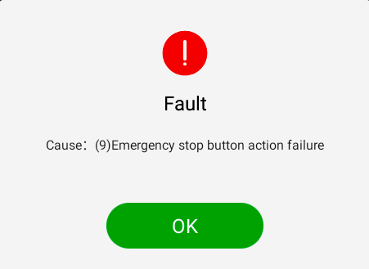

Figure ‑ Fault Message Screen

* To reset the MaxiCharger

1. Ensure that the situation is safe again.
2. Turn the **Emergency Stop** button clockwise to release it.

* The MaxiCharger will start and the error message will disappear from the touchscreen.
* The MaxiCharger will resume the normal operation.

## Charging Procedure

### Screen Layout

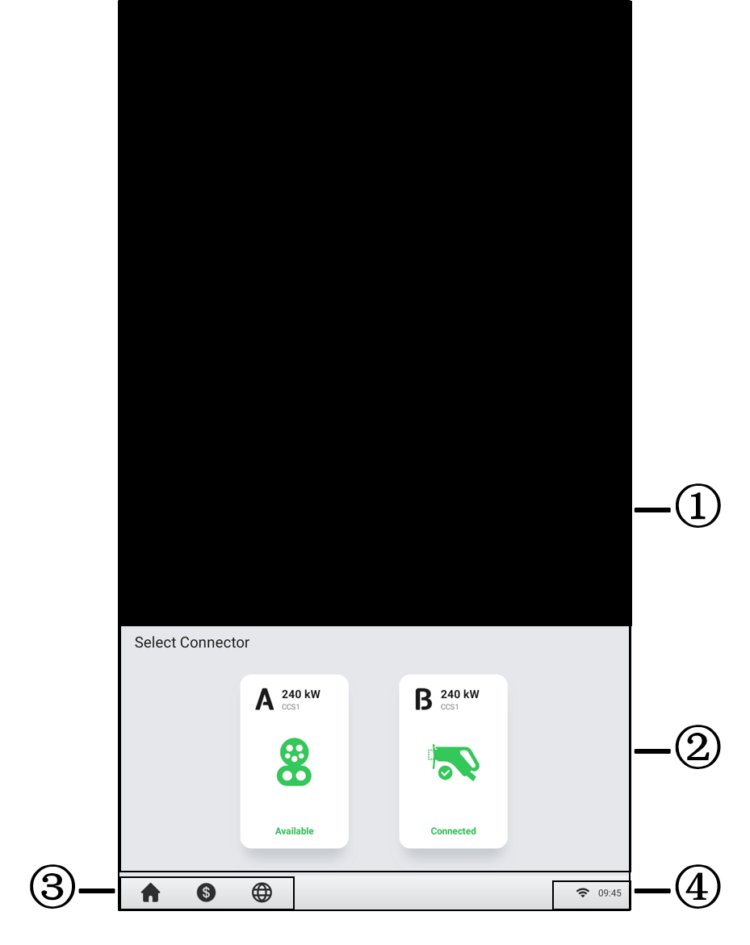

Figure ‑ Standby Screen

① Advertisement page — can be displayed on a full screen and is omitted in the following sample figures

② Connector options — tap to view connector information

③ Home button, cost information, and language options

④ Internet icon — an **x** appearing at the lower corner of the Internet icon indicates the MaxiCharger is not connected to the Internet

After a connector is successfully connected to your EV, the MaxiCharger can automatically recognize the connector, then the corresponding connector’s Authorization Screen will appear.

If no operation is performed for a long time on the Authorization Screen, the Standby Screen will appear. Manually select the appropriate connector on the touchscreen.

### Authorization

IMPORTANT

* Observe the screen for any abnormalities, such as an error messages, before starting a charge session. Check the surroundings and the MaxiCharger for any abnormalities or damage as well.
* If the screen displays an error message, DO NOT use the MaxiCharger. Contact Autel Technical Support.

When the Authorization Screen appears, you can use any of the following methods to start a charge session.

* Scan the QR code on the screen
* RFID card
* Plug & charge (supports the ISO 15118 PnC function)
* Credit card (optional)

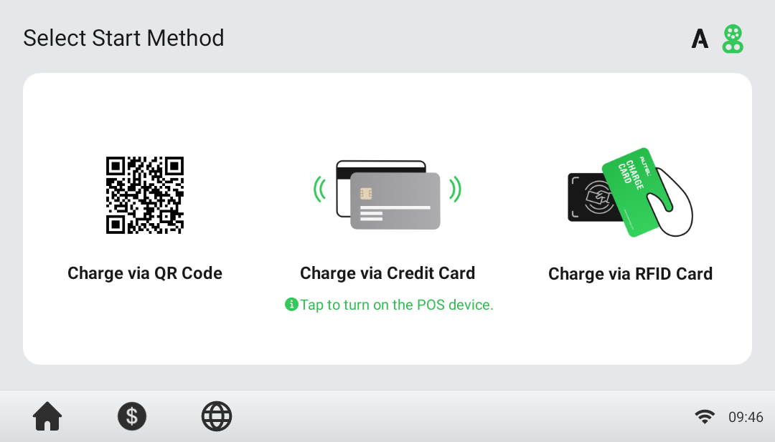

Figure ‑ Authorization Screen

### Start Charging

After authorization, the MaxiCharger will set up communication with your EV and necessary safety tests will be performed. Following the safety tests, the charge session will start automatically.

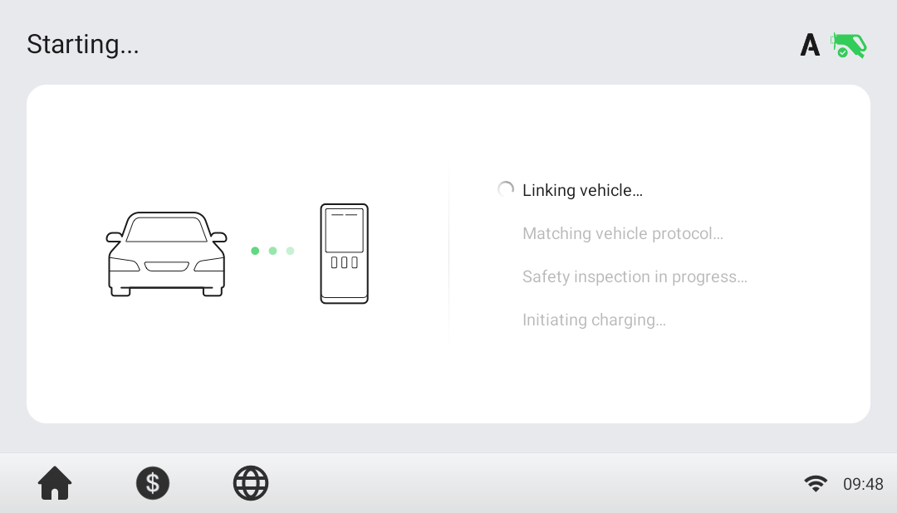

Figure ‑ Start Charging Screen

### Charging

You will be informed of the progress during charging. Information about the charging duration, volume, cost, and power will appear on the Charging Screen. Tap the right arrow button on the right to view more information about the charging status, including SOC (State of Charge), current, and voltage.

Wait until your EV is fully charged or terminate the charge session by tapping the **Stop** button on screen.

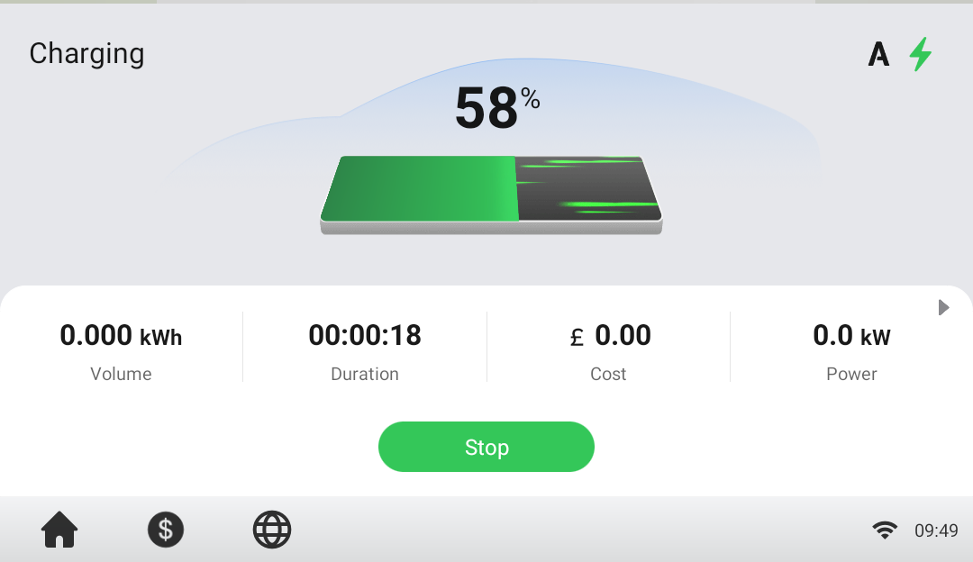

Figure 6‑5 Charging Screen

### Stop Charging

* To stop charging

1. Tap the **Stop** button on the screen.

NOTE

When the battery is full, the charge session stops automatically.

1. Normally, you have to authorize again to finish charging, using the same authentication method as was used to start:

* QR code: Tap the **Stop** button on the Charging Screen of the Autel Charge app.
* RFID card: Put the RFID card on the card reader again to finish charging.
* Credit card: Finish charging directly.

1. When charging is finished, your order details will appear.

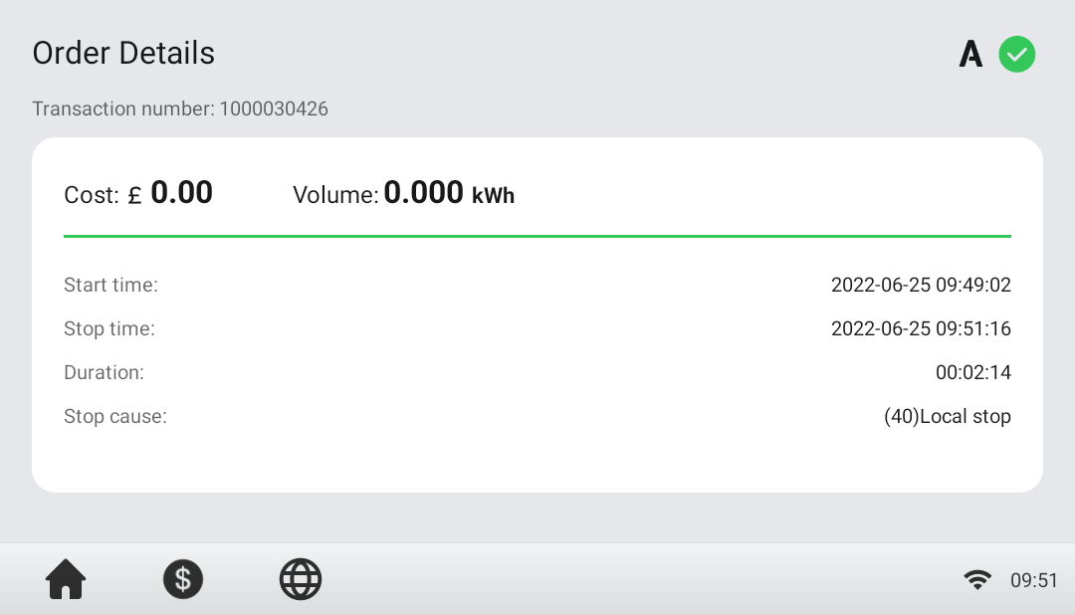

Figure ‑ Order Details Screen

1. Disconnect the EV charging cable from the EV.
2. Put the EV charging cable in the connector holder on the MaxiCharger.

### Finish Charging

Return the connector to the holster on the MaxiCharger.

## Charging Errors

This section depicts several common problems that may arise during your charging session, along with possible causes/solutions to help you resolve those problems. If the problem persists, contact your local dealer or Autel Technical Support.

### Connector Connection Error

If the connector is not properly connected to your EV, then the Connector Not Connected screen will appear. Insert the connector into your EV’s charge port and check the connection.

### Authorization Failure

If an error occurs when you start the authorization process but without starting charging, the Authorization Failure screen will appear. The cause and possible solution(s) will display on the screen. Follow the on-screen instructions to resolve the problem, or contact your local dealer or Autel technical support.

### Charging Start Failure

If an error occurs when you start charging, the Charge Start Failure screen will appear. The cause and possible solution(s) will display on the screen. Follow the on-screen instructions to resolve the problem.

### Charging Failure

If an error occurs during charging, the Charging Failure screen will appear. The cause and possible solution(s) will display on the screen. Follow the on-screen instructions to resolve the problem, or contact your local dealer or Autel Technical Support.

## Energizing the MaxiCharger

* To energize the MaxiCharger

1. Close the front door.
2. Set the upstream breaker that provides power to the MaxiCharger to **ON**.

The MaxiCharger will start and be ready for operation.

## De-energizing the MaxiCharger

* To de-energize the MaxiCharger

1. Set the upstream breaker which provides the power to the MaxiCharger to **OFF** and lock it. Make sure that this breaker stays in the **OFF** position during the procedure.
2. Open the front door.
3. Measure the AC voltage by referring to Measuring the AC Voltage.Make sure that all the measured voltages are 0 volts.
4. Measure the DC voltage by referring to Measuring the DC Voltage. Make sure that all the measured voltages are 0 volts.
5. Close the door.

### Measuring the AC Voltage

Use a voltage tester to measure the AC voltage between the terminals on the surge protection device switch:

* L1 to L2
* L1 to L3
* L2 to L3
* N to L1/L2/L3

NOTE

The surge protection device switch shows the indica tions N, L1, L2, and L3.

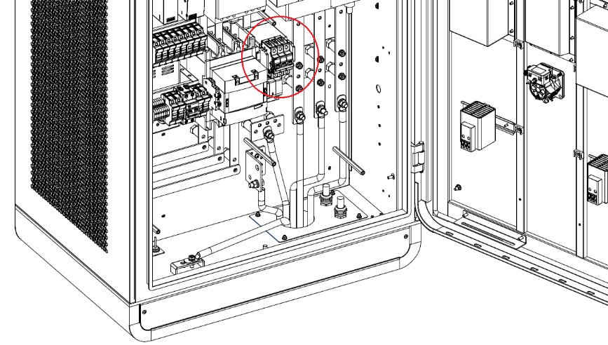

Figure ‑ Measuring the AC Voltage

### Measuring the DC Voltage

Remove the insulating barrier and use a voltage tester to measure the DC voltage between the output terminals, make sure that all the measured voltages are 0 volts.

* Power module group output 1 — (A) to power module group output 1+ (B)
* Power module group output 2 — (C) to power module group output 2+ (D)
* EV charging cable 1 output — (E) to EV charging cable 1 output + (F)
* 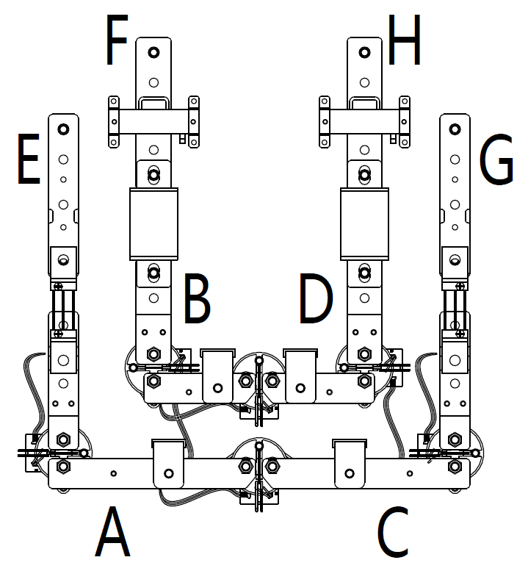EV charging cable 2 output — (G) to EV charging cable 2 output + (H)

Figure ‑ Output Terminals Diagram

## Removing Condensation

NOTE

If the MaxiCharger is off for more than two hours, condensation can occur.

* To remove condensation from the cabinet

1. Open the front door.
2. Set the main breaker from the **ON** to the **OFF** position.
3. Energize the MaxiCharger.
4. Close the door. Wait 2 hours. The internal heater of the cabinet will heat the inside of the cabinet and the condensation will evaporate.
5. Open the front door.
6. Set the main breakers from the **OFF** position to the **ON** position.
7. Close the door.

## Local Service Portal Operations

### Setting the OCPP Parameters

NOTE

The OCPP parameter setting should be performed by an installation engineer.

* To set the OCPP parameters

1. Tap the upper-left corner of the screen.
2. Tap **Device Maintenance**. Enter the default password (contact Autel customer service to obtain the password).
3. Tap **Set Parameters**. Wait for the system to load the data. This can take a few seconds.
4. (Optional) On the screen, tap the column of desired parameter values to modify the data for these subjects:

* **Running environment**: current running environment
* **OCPP IP**: IP address of the OCPP
* **OCPP URL**: URL of the OCPP
* **OCPP PORT**: port number of the OCPP
* **MGR IP**: IP address of the management platform
* **MGR URL**: URL of the management platform
* **MGR PORT**: port number of the operational management platform

NOTE

Make sure that you type the URL or ID correctly and without spaces.

1. Tap **Save** to save your changes.

# Maintenance

## Routine Maintenance

Routine maintenance can keep the MaxiCharger in safe and stable state.

* Clean the cabinet every quarter: tighten the screws and bolts of key parts, and check whether the wire connection of the MaxiCharger’s connector is burned out. If any abnormality is found, replace the parts promptly.
* Clean the air filter and dust filter at least twice a year.
* Test the residual current device once a year.

WARNING

* Disconnect the power supply to the MaxiCharger during the entire maintenance procedure.
* Make sure that unauthorized personnel are kept at a safe distance during maintenance.
* Wear proper personal protective equipment, such as protective clothing, safety gloves, safety shoes, and safety glasses.
* If you remove the safety devices for maintenance, reinstall them after completing the work.

### Residual Current Device Maintenance

The internal residual current device (RCD) and residual current breaker with overload (RCBO) should be tested annually for correct functioning. Before testing, disconnect the MaxiCharger with the EV and stop any charging processes.

* To test the residual current device

1. Open the front door of the MaxiCharger. When the cabinet door is opened, the MaxiCharger should not be directly exposed to wind and rain.
2. The MaxiCharger must be in Standby mode. Tapping the touchscreen will wake up the MaxiCharger.
3. Locate the RCD (under the MCCB), and press the **Test** button of the MaxiCharger to start the test.

* Pass: The MaxiCharger stops operation when the MCCB is set to the middle position. The MaxiCharger starts operation again when the MCCB is set to the **OFF** then **ON** position.
* Fail: There is no response when pressing the **Test** button. Please disconnect the AC power of the MaxiCharger and close the cabinet door, then contact Autel technical support or your local dealer. Do not use the MaxiCharger until the repair is complete.

1. Locate the RCCB, and press the **Test** button of the device to start test.

* Pass: The auxiliary power supply stops working when the RCCB is set to the **OFF** position. The auxiliary power supply starts working again when the RCCB is set to the **ON** position.
* Fail: There is no response when pressing the **Test** button. Please disconnect the AC power of the MaxiCharger and close the cabinet door, then contact Autel technical support or your local dealer. Do not use the MaxiCharger until the repair is complete.

1. Close the front door of the MaxiCharger after the test is finished.
2. Mark the time when the test is needed to be repeated annually.

### Cleaning the Cabinet

The cabinet is powder-coated. The coating must be kept in good condition. When the MaxiCharger is in a corrosion sensitive environment, superficial rust may appear on welding points. Visible rust has no risk to the integrity of the cabinet.

* To remove rust

1. Stop any charging processes and power off the MaxiCharger.
2. Remove rough dirt by spraying with low-pressure tap water.
3. Apply a neutral or weak alkaline cleaning solution and let it soak.
4. Remove dirt by hand with a damp and non-woven nylon cleaning pad.
5. Rinse thoroughly with tap water.
6. Apply wax or a rust-preventive primer for extra protection if needed.

WARNING

* Before cleaning, stop any charging processes and do not connect the power to the MaxiCharger. Failure to do so may cause damage and/or personal injury or death.
* Do not apply high-pressure water jets and avoid water leaking into the MaxiCharger. Make sure that the inside of the MaxiCharger is dry during cleaning.
* Do not use caustic solvents, sprays, solvents or abrasives. Use cleaning agents with a pH between 6 and 8 for strong stains only.

### Cleaning and Replacing the Air Filters

WARNING

* Before cleaning, stop any charging processes and do not connect the power to the MaxiCharger. Failure to do so may cause damage and/or personal injury or death.
* Do not apply high-pressure water jets and avoid water leaking into the MaxiCharger. Make sure that the inside of the MaxiCharger is dry during cleaning.
* Do not use caustic solvents, sprays, solvents or abrasives.

The MaxiCharger is equipped with an air inlet filter and an air outlet filter with a large mesh area to prevent the electronic components from being damaged by dust. Clean the air filters every 3 months (not to exceed 6 months). Replace the air filters annually.

* To clean or replace the air inlet filter

1. Before cleaning and replacing, be sure to stop all charging processes, disconnect the external power supply, and perform the power-off protection.
2. Open the right-side door of the MaxiCharger. When the cabinet door is opened, the MaxiCharger should not be directly exposed to wind and rain.
3. Remove the bezel (D) after removing the screws (C) using a screwdriver and take out the fixing board (B) and air inlet filter (A).
4. Clean the air inlet filter of debris or dust and reinstall the cleaned filter. Alternatively install a new air inlet filter.
5. Reinstall the bezel and screws.
6. Close the right-side door of the MaxiCharger.

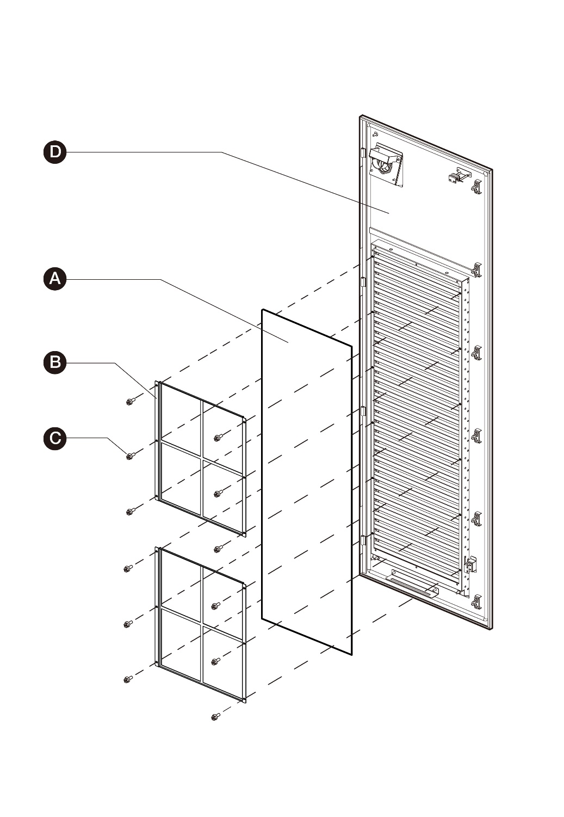

Figure ‑ Air Inlet Filter View

* To clean or replace the air outlet filter

1. Before cleaning and replacing, be sure to stop all charging processes, disconnect the external power supply, and perform the power-off protection.
2. Open the left-side door of the MaxiCharger. When the cabinet door is open, the MaxiCharger should not be directly exposed to wind and rain.
3. Remove the bezel (with fans) (D) after removing the screws (C) using a screwdriver and take out the fixing board (B) and air outlet filter (A). Be sure that the bezel cannot be placed on the floor after taking out the air outlet filter. It should be hung on the left-side door or held in the hand to prevent the cables of the fans from being pulled off.
4. Clean the air outlet filter of debris or dust and reinstall the cleaned filter. Alternatively install a new air outlet filter.
5. Reinstall the bezel and screws.
6. Close the left-side door of the MaxiCharger.

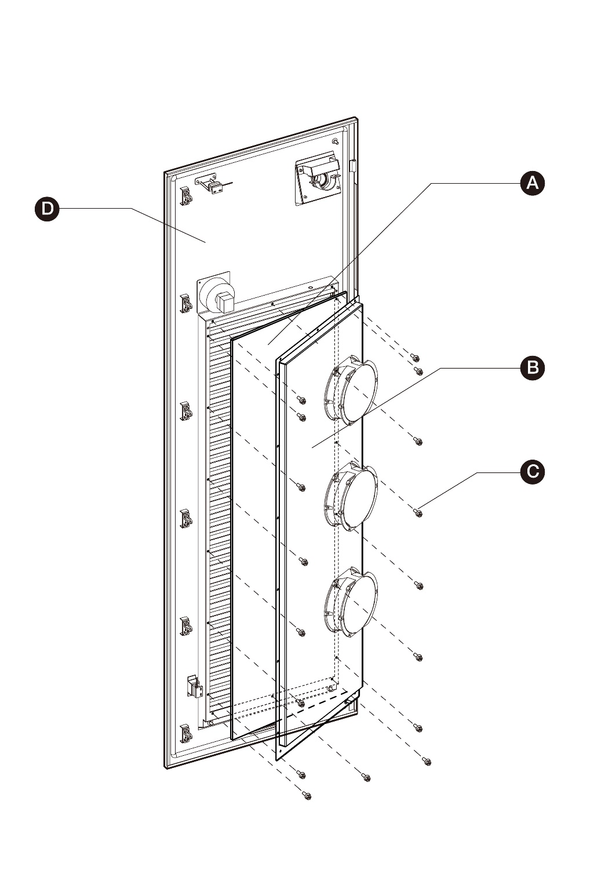

Figure ‑ Air Outlet Filter View

## Inspection and Maintenance

When the MaxiCharger operates normally, only routine maintenance is needed.

When the MaxiCharger operates abnormally, refer to Troubleshooting to resolve the problem or contact your local dealer or Autel Technical Support promptly.

When parts need to be replaced, completely cut off the power supply upstream and inside the equipment before operating.

Regularly conduct a visual inspection of the following points:

* Cable and connector: Check for cracks or ruptures on the connector or cable.
* Display: Check for damage and cracks. Check whether the touchscreen works.
* Cabinet coating: Check for damage, cracks or ruptures.
* Cabinet: Check for rust or damage.

The following special inspections are needed for safe use:

* Check if the MaxiCharger was struck by lightning.
* Check if the MaxiCharger was damaged due to an accident or fire.
* Check the MaxiCharger installation site has been flooded.

WARNING

Stop any charging processes and do not connect the power to the MaxiCharger until all the inspections are complete.

## Remote Maintenance

The MaxiCharger has the function of connecting to cloud platform to monitor parameters in real time. This provides remote upgrades, remote diagnosis, and remote service functions, and can timely identify and locate problems in the operation process.

* System self-check for abnormality daily.
* If any operation abnormality is found, contact your local dealer or Autel technical support promptly.
* Autel service engineers can check logs, update configurations and programs, and provide remote maintenance services, such as remote management, diagnosis, configuration, and upgrades.

## Maintenance Schedule

Table ‑ Maintenance Schedule

|  |  |  |
| --- | --- | --- |
| **Item** | **Frequency** | **Actions** |
| **Connector** | Every 3 months | Check for cracks or ruptures on the connector. |
| **Input Cable** | Every 3 months | Check for cracks or ruptures on the cable. |
| **Inlet Air Filter** | Annually | Replace the inlet air filter. |
| **Outlet Air Filter** | Annually | Replace the outlet air filter. |
| **Cabinet** | Every 3 months | Clean and check for damage, including the air filters. |

# Troubleshooting and Service

## Troubleshooting

1. Try to find a solution for the problem with the aid of the information in this document.
2. If you cannot find a solution for the problem, contact your local Autel representative or Autel Technical Support.

Table ‑ Troubleshooting Details

| Issue | Possible Cause | Solution | Handler |
| --- | --- | --- | --- |
| **The touchscreen displays: Emergency stop button action failure.** | The emergency stop button was pressed by mistake. | Turn the switch to the position as instructed. | Customer Technical Support |
| Screen Not Displaying | No power supply to the MaxiCharger. | * Check the power supply to the upstream distribution box. * Open the front door and check the RCD breaker of auxiliary branch. * Use the mulitmeter to test the power input. | Customer Technical Support/  Autel Technical Support |
| The touchscreen displays a message: Unable to lock the connector. | The connector is not connected correctly to the EV. | * Plug the connector into the EV charging port correctly and retry. * Try another MaxiCharger to charge the EV. | Customer Technical Support/  Autel Technical Support |
| The touchscreen displays a message: Insulation error detected. | There is an insulation problem on the EV or the MaxiCharger. | * Try another MaxiCharger to charge the EV. * Contact Autel technical support. | Customer Technical Support/  Autel Technical Support |
| QR Code Scanning Failure | Cellular network failure | Ensure that the network SIM card is properly installed. | Customer Technical Support/  Autel Technical Support |
| Local network failure | Check local network connection. | Customer Technical Support/  Autel Technical Support |
| RFID Card Reading Failure | The RFID card is not recognized. | * The RFID card broken. * No RFID card data on the cloud. * Use a new RFID card. | Customer Technical Support |
| Insufficient balance | Contact the operator for top-up. | Customer Technical Support |
| Internet failure | See "QR Code Scanning Failure" solutions above. | Customer Technical Support/  Autel Technical Support |
| Charging Failure | The connector is not properly connected. | * Check the connector connection and reconnect it. * Try another MaxiCharger to charge the EV. | Customer Technical Support/  Autel Technical Support |
| EV error | * Try another MaxiCharger to charge the EV. * Contact your EV manufacturer for support. | EV dealer/  EV manufacturer |
| Charger error | * Try another MaxiCharger to charge the EV. * Contact Autel technical support. | Customer Technical Support/  Autel Technical Support |
| **Others** | Other issues | Contact Autel technical support. | Autel Technical Support |

## Service

If you cannot find solutions to your problems with the aid from the table above, please contact Autel Technical Support.

AUTEL Europe

* **Phone**: +49(0)89 540299608 (Monday–Friday, 9:00 AM–6:00 PM Berlin Time)
* **Email**: evsales.eu@autel.com; evsupport.eu@autel.com
* **Address**: Landsberger Str. 408, 4. OG, 81241 Munich, Germany

# Technical Specifications

## General Specifications

Table ‑ Product Specifications

| Parameter | Description |
| --- | --- |
| **Compliance and Safety** | * IEC 61851-1 * IEC 61851-23 * IEC 61851-21-2 * IEC 61000 |
| **IP Rating** | IP54 |
| **IK Rating** | IK10 |
| **Short Circuit Current Rating** | 35 kA |
| **EMC** | * Class A * Class B optional |
| **Output Voltage** | * CCS: 150 to 950 V DC * CHAdeMO: 150 to 500 V DC |
| **Output Current (for MaxiCharger DF120)** | * CCS: 200 A * CHAdeMO: 125 A/200 A |
| **Output Current (for MaxiCharger DF240)** | * CCS: 200 A * CCS boost: 300 A (peak 400 A) * CHAdeMO: 125 A/200 A |
| **EV Charging Cable Length** | * 4 m (157.48") * 7.5 m (295.28") |
| **Certification** | * CE * UKCA * TR25 |
| **Maximum noise level at a distance of 1 m** | < 65 dB @ 1m /25 °C/full load |
| **Input AC Power Connection** | 3P + N + PE |
| **Input Voltage Range** | 400 V AC ±10% |
| **Power Factor at Full Load** | >= 0.98 |
| **Peak Efficiency** | >= 96% |
| **Total Harmonic Distortion**  **(current / > 50% load)** | <= 5% |

Table ‑ Operating Conditions

| Parameter | Specification |
| --- | --- |
| **Environment, general** | * Indoor * Outdoor |
| **Storage Temperature** | -40 to +70 °C (-40 to 158 °F) |
| **Operation temperature range** | * -35 to + 55 °C (-31 to +131 °F) * +50 to +55 °C (+122 to +131 °F) with linear power de-rating |
| **Maximum altitude above sea level** | < 2000 m (6561') |

## Packaging Specifications

Table ‑ General Dimensions

| Parameter | Specification | | | |
| --- | --- | --- | --- | --- |
| MaxiCharger DF120 | | MaxiCharger DF240 | |
| **Width of the Cabinet** | 820 mm | 32.28 in | 820 mm | 32.28 in |
| **Depth of the Cabinet** | 600 mm | 23.62 in | 700 mm | 27.56 in |
| **Height of the Cabinet** | 1950 mm | 76.77 in | 1950 mm | 76.77 in |
| **Length of the charging cable (air-cooled)** | 4000 mm (157.48 in) | | | |
| (Optional) 7500 mm (295.28 in) | | | |

Table ‑ Packaged Product Specifications

| Parameter | Specification | |
| --- | --- | --- |
| **Width** | 1240 mm | 48.82 in |
| **Depth** | 1000 mm | 39.37 in |
| **Height** | 2146 mm | 84.49 in |
| **Mass of the Package** | 55 kg | 121 lb. |
| **Maximum Tipping Angle** | 30° | |
| **NOTE**: The MaxiCharger is mounted on a standard size wooden pallet and protected to prevent damages during transport. | | |

## Installation Specifications

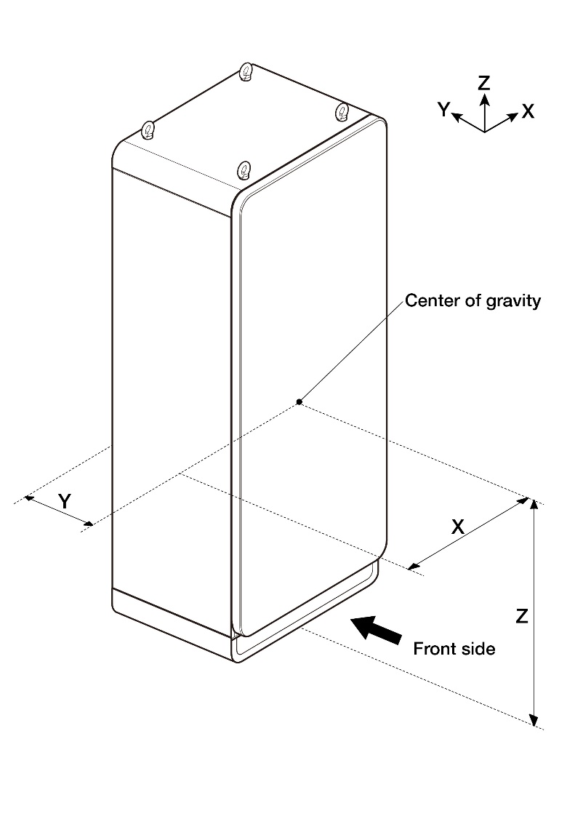

Figure ‑ Center of Gravity

Table ‑ Center of Gravity Specifications

| Parameter | Specification | | | |
| --- | --- | --- | --- | --- |
| MaxiCharger DF120 | | MaxiCharger DF240 | |
| **X** | 400 mm | 15.75 in | 400 mm | 15.75 in |
| **Y** | 330 mm | 12.99 in | 300 mm | 11.81 in |
| **Z** | 840 mm | 33.07 in | 840 mm | 33.07 in |

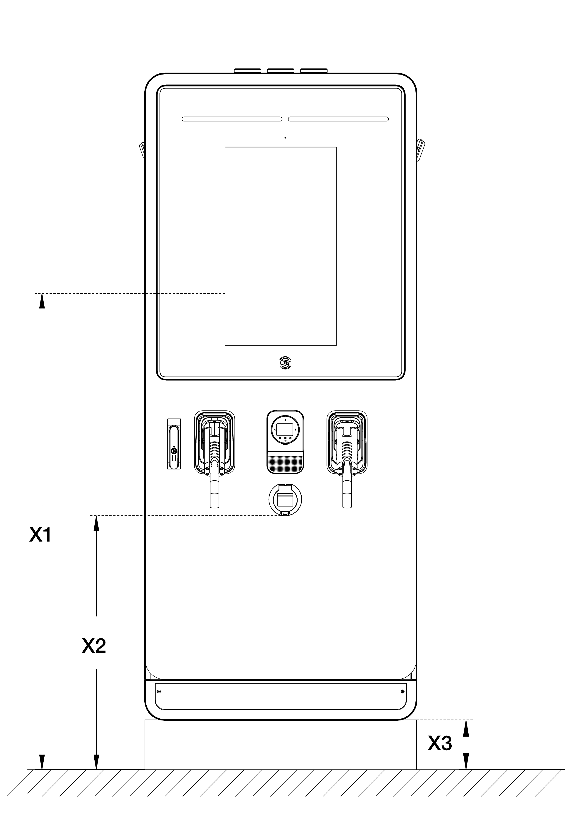

Figure ‑ Operable Element Specifications

Table ‑ Operable Element Specifications

| Parameter | Description | Specification | |
| --- | --- | --- | --- |
| mm | in |
| **X1** | Highest user operable element of MaxiCharger | 1350 | 53.15 |
| **X2** | Lowest user operable element of MaxiCharger | 766 | 30.16 |
| **X3** | Foundation height of MaxiCharger | 150 | 5.91 |

Table ‑ Items Included in the Delivery

| Item | Description |
| --- | --- |
| **MaxiCharger** | For details, see Product Overview. |
| **Door Key** | Door key for the cabinet |

NOTE

It is possible that more parts are required in the delivery. Refer to the order.

## Communication Interface Specifications

Table ‑ Communication Interface Specifications

| Parameter | Specification |
| --- | --- |
| **RFID Standard** | ISO 14443 A + B to part 4 ISO/IEC 15693 |
| **RFID-supported Applications** | * Mifare * NFC * Calypso * Ultralight, Pay-Pass * HID   For information about the options, contact the manufacturer. |
| **Network Connection** | * 3G/4G modem * 10/100 Base-T Ethernet * WiFi |

Table ‑ Ethernet Cable Specifications

| Parameter | Specification |
| --- | --- |
| **Ethernet Type** | RJ45 |
| **Cable Type** | 8P + PE, Shielded |
| **Bandwidth, Upload** | Minimum 128 Kbit/s |
| **Bandwidth, Download** | Minimum 4 Mbit/s |
| **Availability** | 99.9% |

## Power Rating Specifications

Table ‑ Rating During Normal Duty Operation

| Parameter | Specification |
| --- | --- |
| **MaxiCharger DF40** | 40 kW |
| **MaxiCharger DF60** | 60 kW |
| **MaxiCharger DF80** | 80 kW |
| **MaxiCharger DF100** | 100 kW |
| **MaxiCharger DF120** | 120 kW |
| **MaxiCharger DF160** | 160 kW |
| **MaxiCharger DF180** | 180 kW |
| **MaxiCharger DF200** | 200 kW |
| **MaxiCharger DF220** | 220 kW |
| **MaxiCharger DF240** | 240 kW |
| Normal duty operation applies for use in public applications with moderate traffic. | |

Table ‑ De-rating During Normal Duty Operation

| Ambient Temperature | | Power Output (%) | De-rating (%) |
| --- | --- | --- | --- |
| ℃ | ℉ |
| -35 to +50 | -31 to +122 | 100 | 0 |
| +50 to +55 | +122 to +131 | 100 to 75% (linear de-rating) | 0 to 25% |
| Steady state rating of the MaxiCharger at specific ambient temperatures. | | | |

## AC Input and DC Output Specifications

Table ‑ AC Input Wire Specifications

| Parameter | Specification |
| --- | --- |
| **Wire Shielding (optional)** | If the local regulations require shielded wires, connect the wire shielding to the PE bus at both ends of the wire. |
| **Diameter of the Phase Conductors** | Refer to the local regulations. |
| **Diameter of the PE Conductor** | Refer to the local regulations |
| **Surface and Diameter** | Based on the current rating of the MaxiCharger and local regulations. |
| **Material** | Copper |
| **Maximum Temperature of the Input Wires** | 75 °C (167 °F) |

Table ‑ Detail AC Input Specifications

| Type  Parameter | MaxiCharger DF | | | | | | | | | |
| --- | --- | --- | --- | --- | --- | --- | --- | --- | --- | --- |
| 40 | 60 | 80 | 100 | 120 | 160 | 180 | 200 | 220 | 240 |
| **Maximum Rated Input Current (A)** | 62 | 93 | 124 | 155 | 186 | 248 | 280 | 310 | 341 | 372 |
| **Recommended Input Circuit Breaker (A)** | 100 | 125 | 160 | 200 | 250 | 320 | 400 | 400 | 500 | 500 |
| **Maximum Power Dissipation (kVA)** | 43 | 64 | 86 | 107 | 129 | 172 | 193 | 215 | 236 | 258 |
| **Short Circuit Current Rating (kA)** | 35 | 35 | 35 | 35 | 35 | 35 | 35 | 35 | 35 | 35 |
| **Maximum Size of the Input Wire (mm2) (XLPE suggested)** | 120 | 120 | 120 | 120 | 120 | 120 | 120 | 120 | 120 | 120 |

Table ‑ General DC Output Specifications

| Parameter | Specification |
| --- | --- |
| **DC Output Voltage Range, CCS** | 150 to 950 V DC |
| **DC Output Voltage Range, CHAdeMO** | 150 to 500 V DC |
| **Minimum DC Output Current** | 5 A |
| **Connection Standard** | * CCS: IEC 61851-1:2017, IEC 61851-23:2014, IEC 62196-1:2014, IEC 62196-3:2014 * CHAdeMO: CHAdeMO 1.2 |

Table ‑ Detail DC Output Specifications

| Parameter  MaxiCharger | DC Output Power on One EV Charging Cable (kW) | DC Output Power Two EV Charging Cables (kW) | Simultan-eous DC on Two Outlets | Maximum DC Output Current |
| --- | --- | --- | --- | --- |
| **40** | Max.40 kW | Max. 20 kW x 2 | Yes | * CCS connector: 200 A * CHAdeMO connector: 125 A/200 A |
| **60** | Max.60 kW | Max. 40 + 20 kW |
| **80** | Max.80 kW | Max. 40 kW x 2 |
| **100** | Max.100 kW | Max. 60 + 40 kW |
| **120** | Max.120 kW | Max. 60 kW x 2 |
| **160** | Max.160 kW | Max. 80 kW x 2 | * CCS connector: 200 A * CCS boost: 300 A (peak 400 A) * CHAdeMO connector: 125 A/200 A |
| **180** | Max.180 kW | Max. 100 kW +  80 kW |
| **200** | Max.200 kW | Max. 100 kW x 2 |
| **220** | Max.220 kW | Max. 120 kW +  100 kW |
| **240** | Max.240 kW | Max.120 kW x 2 |

NOTE

The actual output power varies in accordance with the voltage rating and maximum current of the selected cable.

## Power Consumption Specifications

Table ‑ Power Consumption during Stand-by

| Parameter | Specification |
| --- | --- |
| **Stand-by Power (Heater Off)** | 0.08 kVA |
| **Stand-by Power (Heater On)** | 1.00 kVA |

NOTE

The heater will operate daily when the outside air reaches the dew point, to avoid condensation inside the cabinet. When the heater operates, the heater will use most of the required standby power.

## Input Short Circuit Current Specifications

Table ‑ Input Short Circuit Current Specifications

| Situation | Specification |
| --- | --- |
| **Rated Peak Withstand Current (kA peak)** | 35 kA |
| **Rated Short-time Withstand Current (kA rms)** | 35 kA |



**www.autelenergy.com**